Anne Frank’s Life
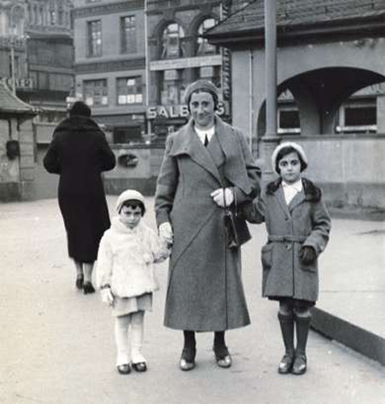
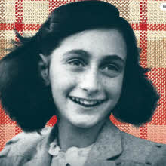
Anne Frank is a Jewish girl who has to go into hiding during World War 2 to escape from the Nazis. Together with seven others, she hides in the secret annex at Prinsengracht 263 in Amsterdam. After more than two years in hiding, the Nazis discovered and deported them to the concentration camps. Anne’s father, Otto Frank, is the only one of the eight people to survive. After her death Anne becomes world famous because of the diary she wrote while in hiding.
LIFE IN GERMANY: Anne Frank was born on 12 June 1929 in the German city of Frankfurt am Main, where her father’s family had lived for generations. She has a sister, Margot, who is three and a half years older. The economic crisis, Hitler’s rise to power and growing antisemitism put an end to the family’s carefree life. Like many other Jews, Otto Frank and his wife, Edith, decide to leave Germany.
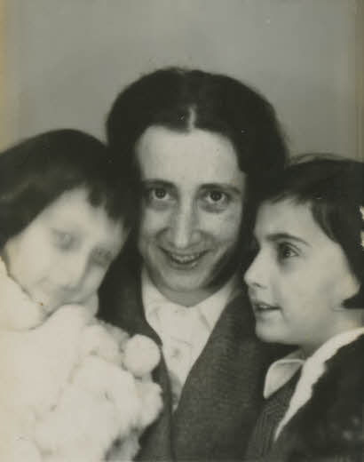
A NEW LIFE IN THE NETHERLANDS
Otto sets up a business in Amsterdam and the family finds a home on the Merwedeplein. The children go to school, Otto works hard at his business and Edith looks after the home. When the threat of war in Europe increases, Otto and his family try to emigrate to England or the USA but these attempts fail. On 1 September 1939, Germany invades Poland. It is the beginning of the Second World War.

WAR IN THE NETHERLANDS
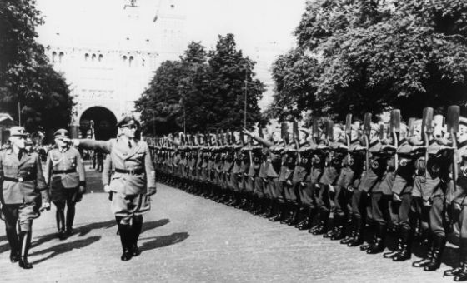

For a while, there is hope that The Netherlands would not be involved in the war, but on 10 May 1940, German troops invade the country. Five days later The Netherlands surrenders and is occupied. Anti-Jewish regulations soon follow. Jews are allowed into fewer and fewer places. Anne and Margot must attend a Jewish school and Otto loses his business.
When a renewed attempt to emigrate to the U.S.A. fails, Otto and Edith decide to go into hiding. Otto sets up a hiding place in the rear annexe of his firm at Prinsengracht 263. He does this together with his Jewish business partner Hermann van Pels and with help from his associates Johannes Kleiman and Victor Kugler.
IN HIDING
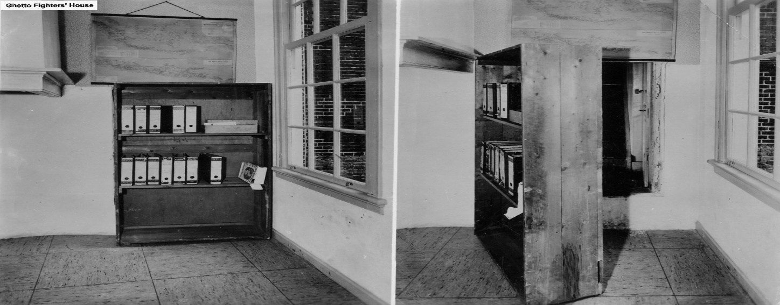

On 5 July 1942, Margot Frank receives a call-up to report for a German work camp. The next day the Frank family goes into hiding. The Van Pels family follows a week later and in November 1942, an eighth person joins them: the dentist Fritz Pfeffer. They remain in the secret annexe for more than two years. In hiding, they have to keep very quiet, are often frightened and pass the time together as well as they can. The office workers help them, Johannes Kleiman, Victor Kugler, Miep Gies and Bep Voskuijl; by Miep’s husband, Jan Gies; and by the warehouse manager, Johannes Voskuijl, Bep’s father. These helpers not only arrange food, clothes and books, they are the group’s contact with the outside world.

A DIARY AS A BESTFRIEND
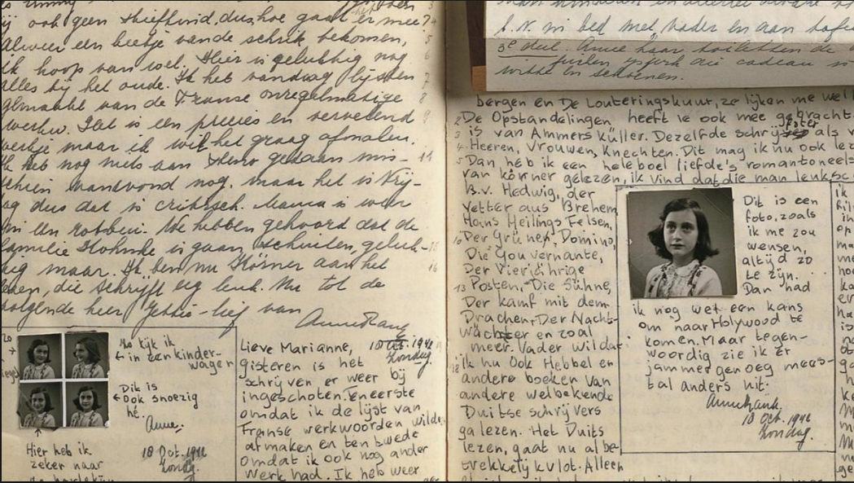
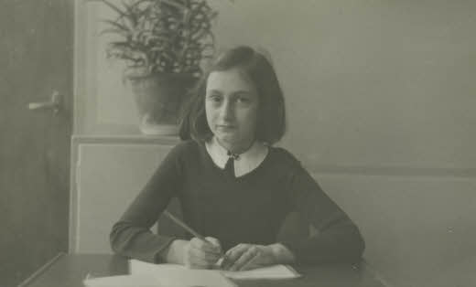

Shortly before going into hiding, Anne receives a diary for her birthday. She starts writing straightaway and during her time in hiding, she writes about events in the secret annex and about herself. Her diary is a great support to her. Anne also writes short stories and collects quotations from other writers in her ‘book of beautiful sentences’.
When the Dutch minister of education in exile in London appeals on British radio for people to keep war diaries, Anne decides to edit her diary and create a novel called 'The Secret Annex'. She starts to rewrite, but Anne and the others, are discovered, and arrested before she has finished.

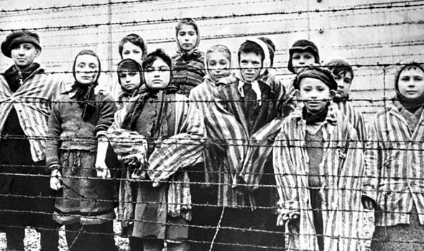
ARREST & DEPORTATION
On 4 August 1944, the people in hiding are arrested, along with their helpers Johannes Kleiman and Victor Kugler. They pass from the security service headquarters and prison to the transit camp Westerbork, from where they are deported to Auschwitz. The two helpers are sent to the Amersfoort camp. Johannes Kleiman is released shortly after his arrest and six months later Victor Kugler escapes. Immediately after the arrests Miep Gies and Bep Voskuijl rescue Anne's diary and papers that have been left behind in the secret annex. Despite intensive investigations, it has never been clear how the hiding place has discovered.

OTTO FRANK RETURNS
Otto Frank is the only one of the eight people in hiding to survive the war. During his long journey back to The Netherlands, he learns that his wife, Edith, has died. He knows nothing about his daughters and still hopes to see them again. He arrives back in Amsterdam at the beginning of July. He goes straight to Miep and Jan Gies and remains with them for another seven years.
Otto Frank tries to find his daughters, but in July, he receives the news that they both died of disease and deprivation in Bergen-Belsen. Miep Gies then gives him Anne’s diary papers. Otto reads the diary and discovers a completely different Anne. He is very moved by her writing.
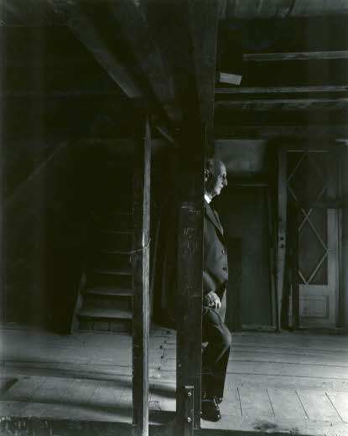

ANNE’S DIARY
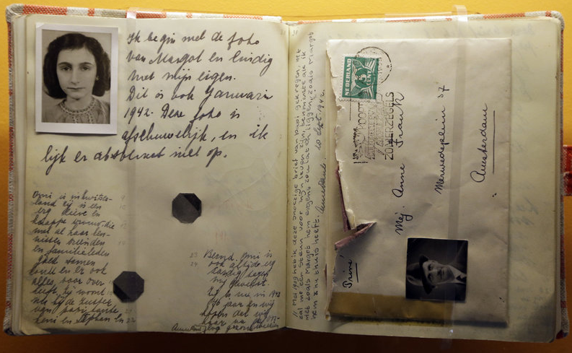
Anne wrote in her diary that she wants to become a writer or a journalist in the future, and that she wants to publish her diary as a novel. Friends convince Otto Frank that the diary has great expressive power and on 25 June 1947, The Secret Annexe is published in an edition of 3,000. Many more editions follow, also translations, a play and a film.
People from all over the world learn of Anne Frank's story. Over the years, Otto Frank answers thousands of letters from people who have read his daughter's diary. In 1960, the Anne Frank House becomes a museum. Otto Frank remains involved with the Anne Frank House until his death in 1980 and campaigns for human rights and respect.

