Read the text and turn the sentences to passive and active as it corresponds.
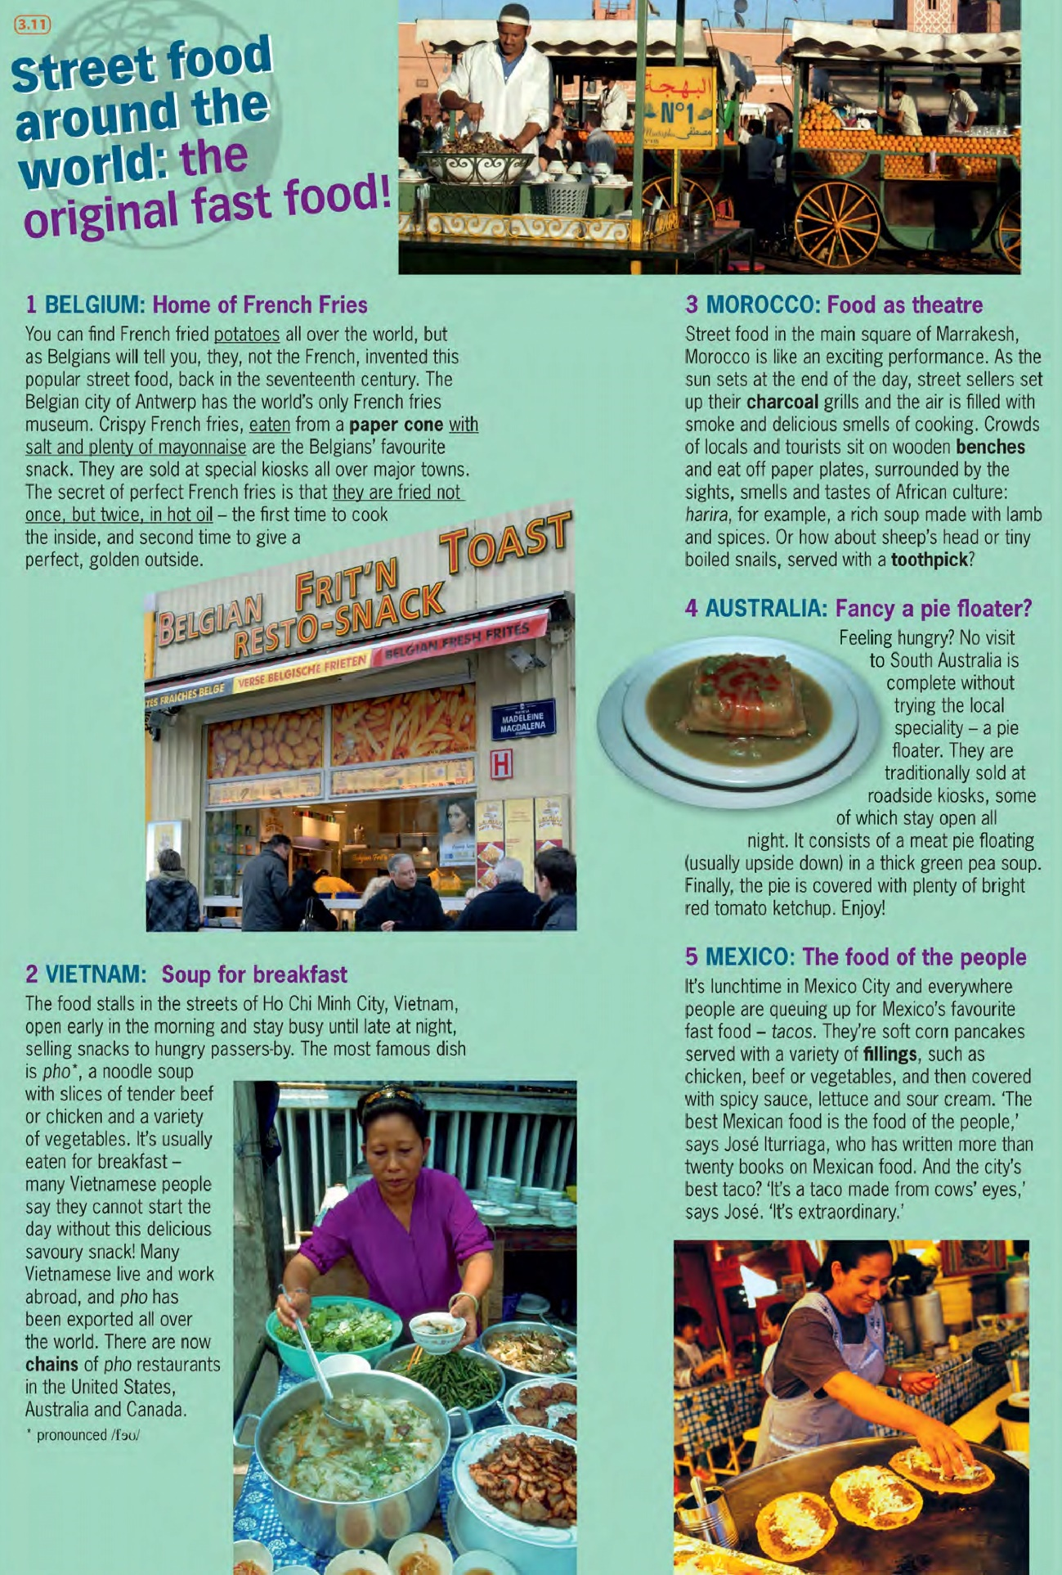

LISTENING
1- Look at the pictures and think about….
- What nationality they are
- Where they live
- What they like eating
- How old they are
- What jobs they do
- What they do at weekends

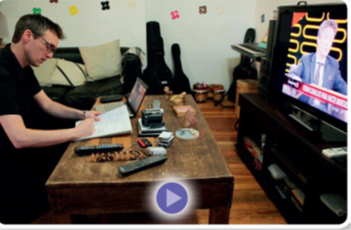
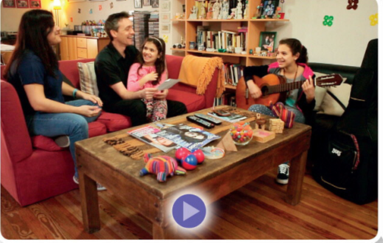

- Watch the video about Menna family and check.
https://www.youtube.com/watch?v=I1aqbMDFOdE

- Watch the video again and choose the right option.

