Unit 1: Fast Food
- Which fast Foods are more popular with teenagers in your country? Which do you like?
- How often do you eat fast food?
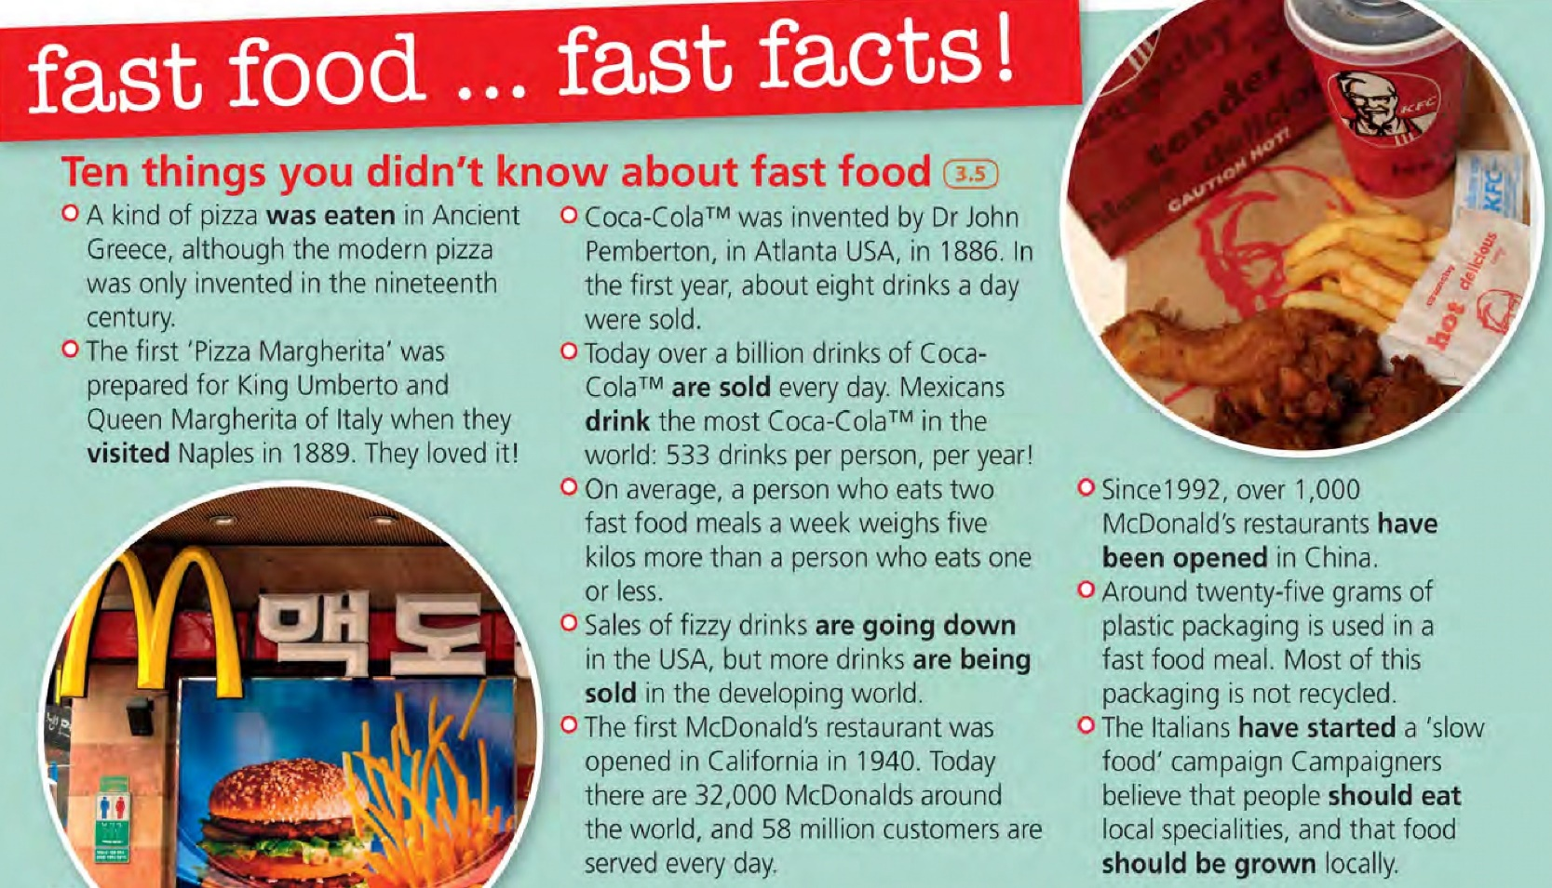

- Read the fast food facts. Tick (√) true and cross (x)false.
- __ The ‘Pizza Margherita’ was invented in the USA.
- __ Coca Cola was a big success immediately.
- __ The average Mexican drinks more Coca Cola than the average American.
- __ People who eat a lot of fast food are generally slimmer than other people.
- __ Fast food creates a lot of rubbish.

- Look at the verbs in bold in the text. Which are passive which are active?

- Make true sentences in the passive using the prompts and your own ideas.
Example: ‘Hamburgers weren’t eaten in this country a hundred years ago’

Vocabulary: PREPARING FOOD

- Look at the cover of a cookbook and discuss the questions.
- What kind of recipes does the cookbook contain?
- What dishes can you see in the photos?
- What are the ingredients, do you think?
- Can you cook your favorite snacks?

- Check the words in blue. Try to put the instruction for each recipe in the correct order.
Writing:

In pairs write a recipe about fast food you generally eat.

