Unit 1: The passive
- Read the text and discuss it.
- When do you think they were made?
- How are they similar or different from televisions today?
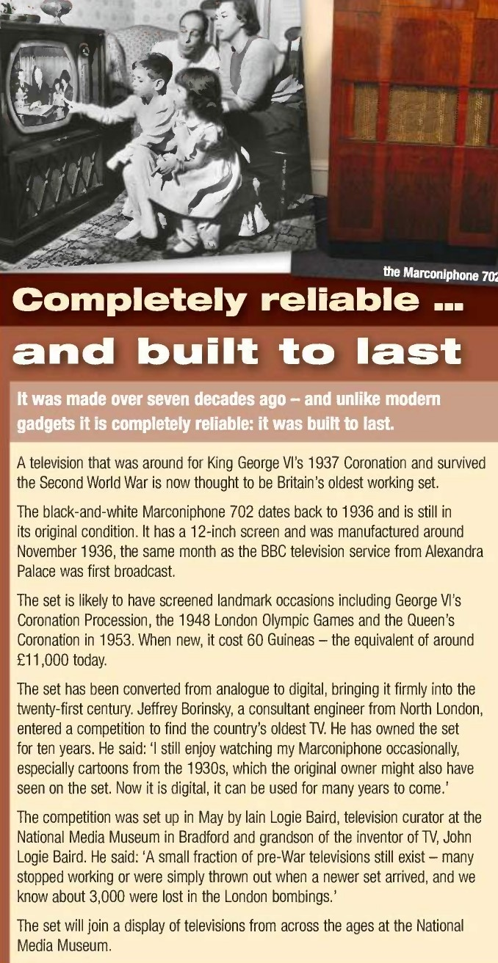

- Read the text again and write true (T), false (F), or not given (NG).
- The television is in excellent working order.
- It was removed from London during the Second World War.
- It is possible to use the television to watch digital TV.
- Jeffrey Borinsky has owned the television since it was made.
- Jeffrey particularly likes watching old programmes on the set.
- The majority of pre-war TVs were destroyed during the War.
- The television will now go to a museum.

- Complete the second sentence so it means the same as the first.
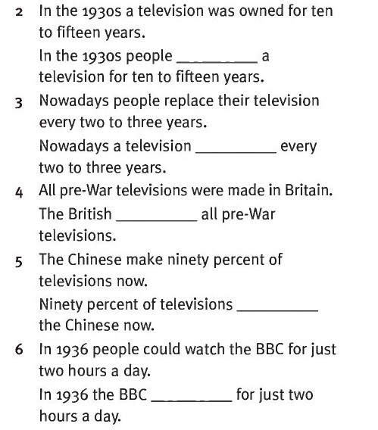

- In pairs, turn the sentences in the text to passive or active voice.

