Unit 1: Fast Food - Have something done
- Read the text about the Tv program ‘A taste of the past’ and discuss it.
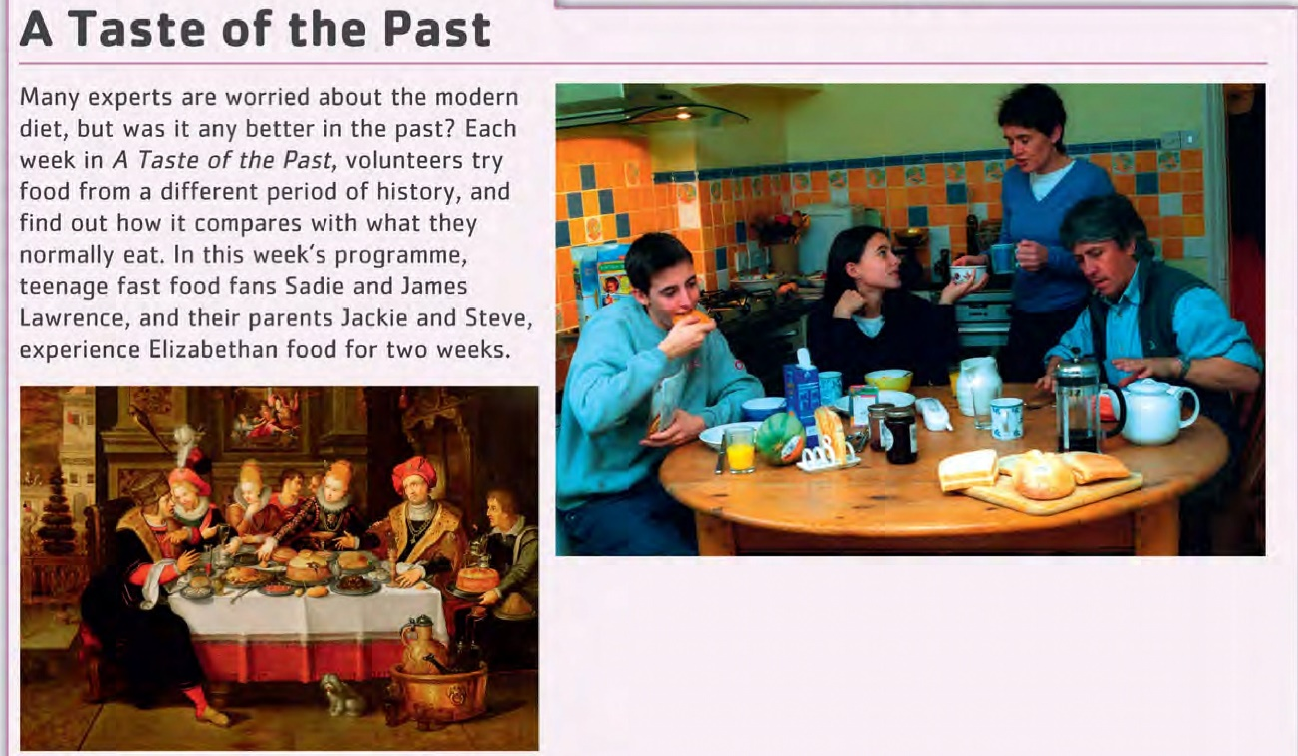
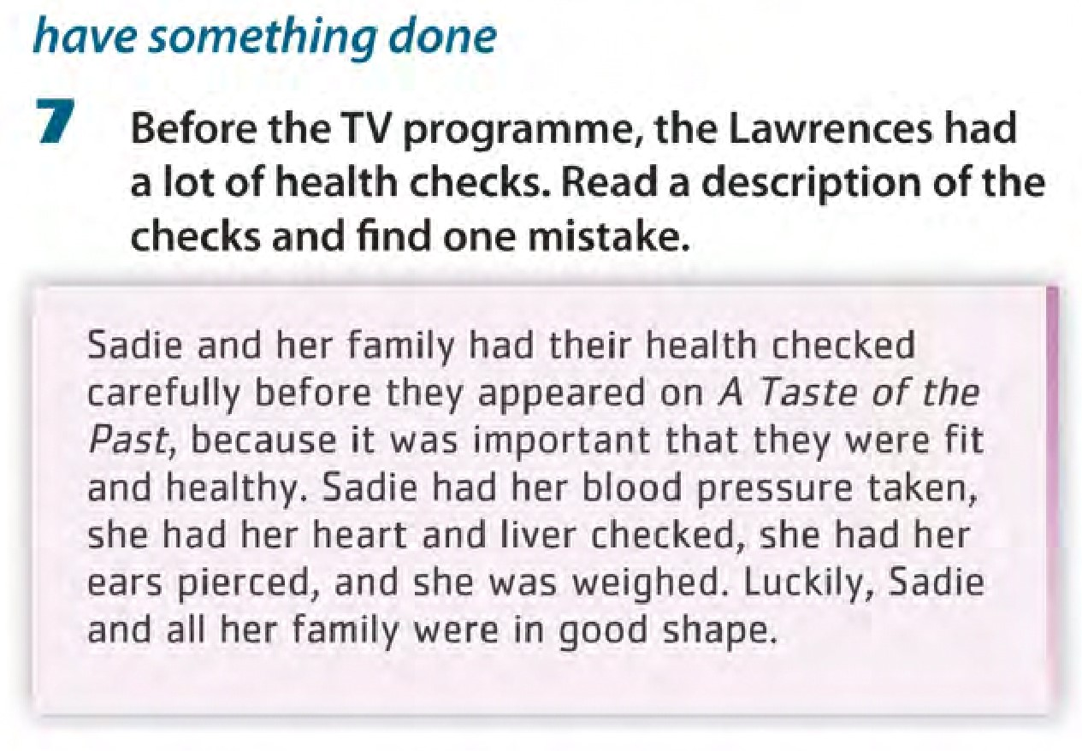
- Write down the sentences that are different and analyse them.
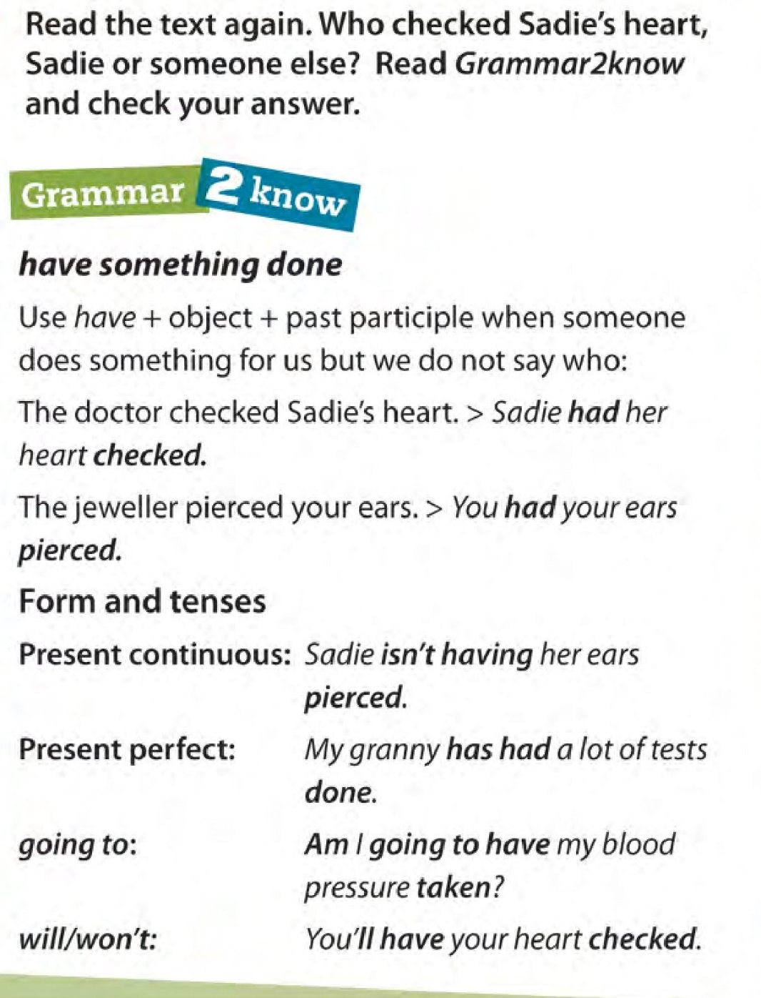
- Use the following prompts to say 4 things you have done and 4 things you don’t have done.
- Eyes/ test - the optician’s
- Hair/ cut -the hairdresser’s
- Clothes/ clean - the drycleaner’s
- Shoes/ repair - the beautician’s
- Teeth/ whiten - the dentist’s
Ex. ‘At the optician’s you have your eyes tested but you don’t have your hair cut.’

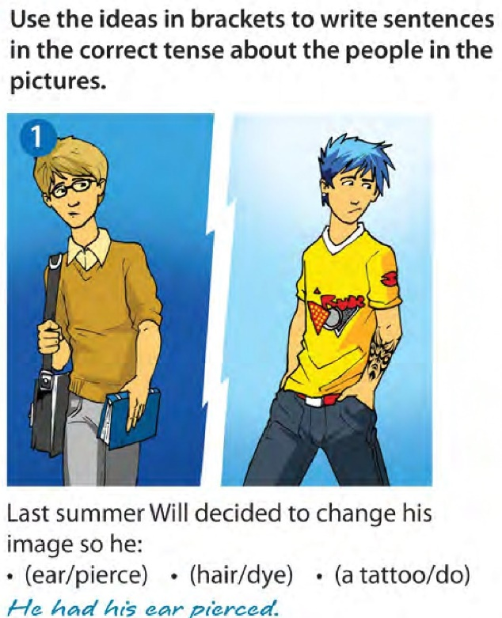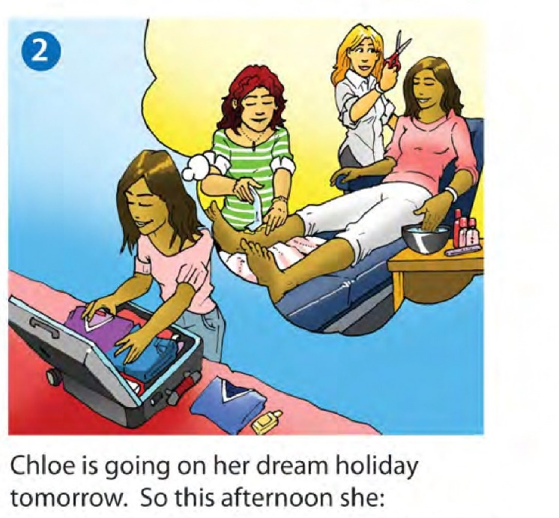
(nails/do) * (legs/wax)
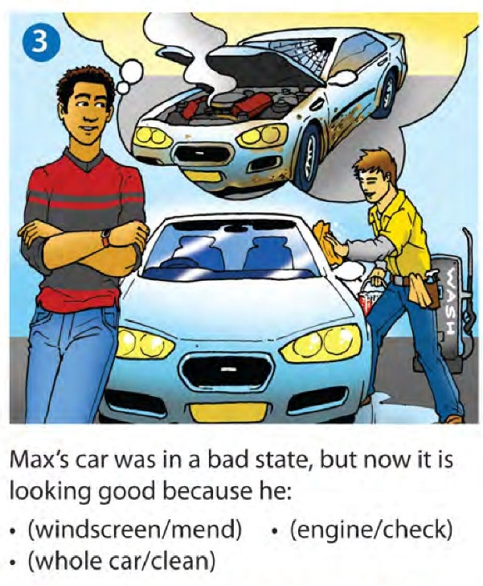

Reading- Speaking
- Look at the pictures in the text and discuss.
- Do you buy snacks in the streets very often?
- What snacks are being sold? which country do you think they are from?
- Look at the following words and find which food in the text they describe.
Sour – crispy – tender – grilled – fried – spicy – sweet – savoury – rich- boiled
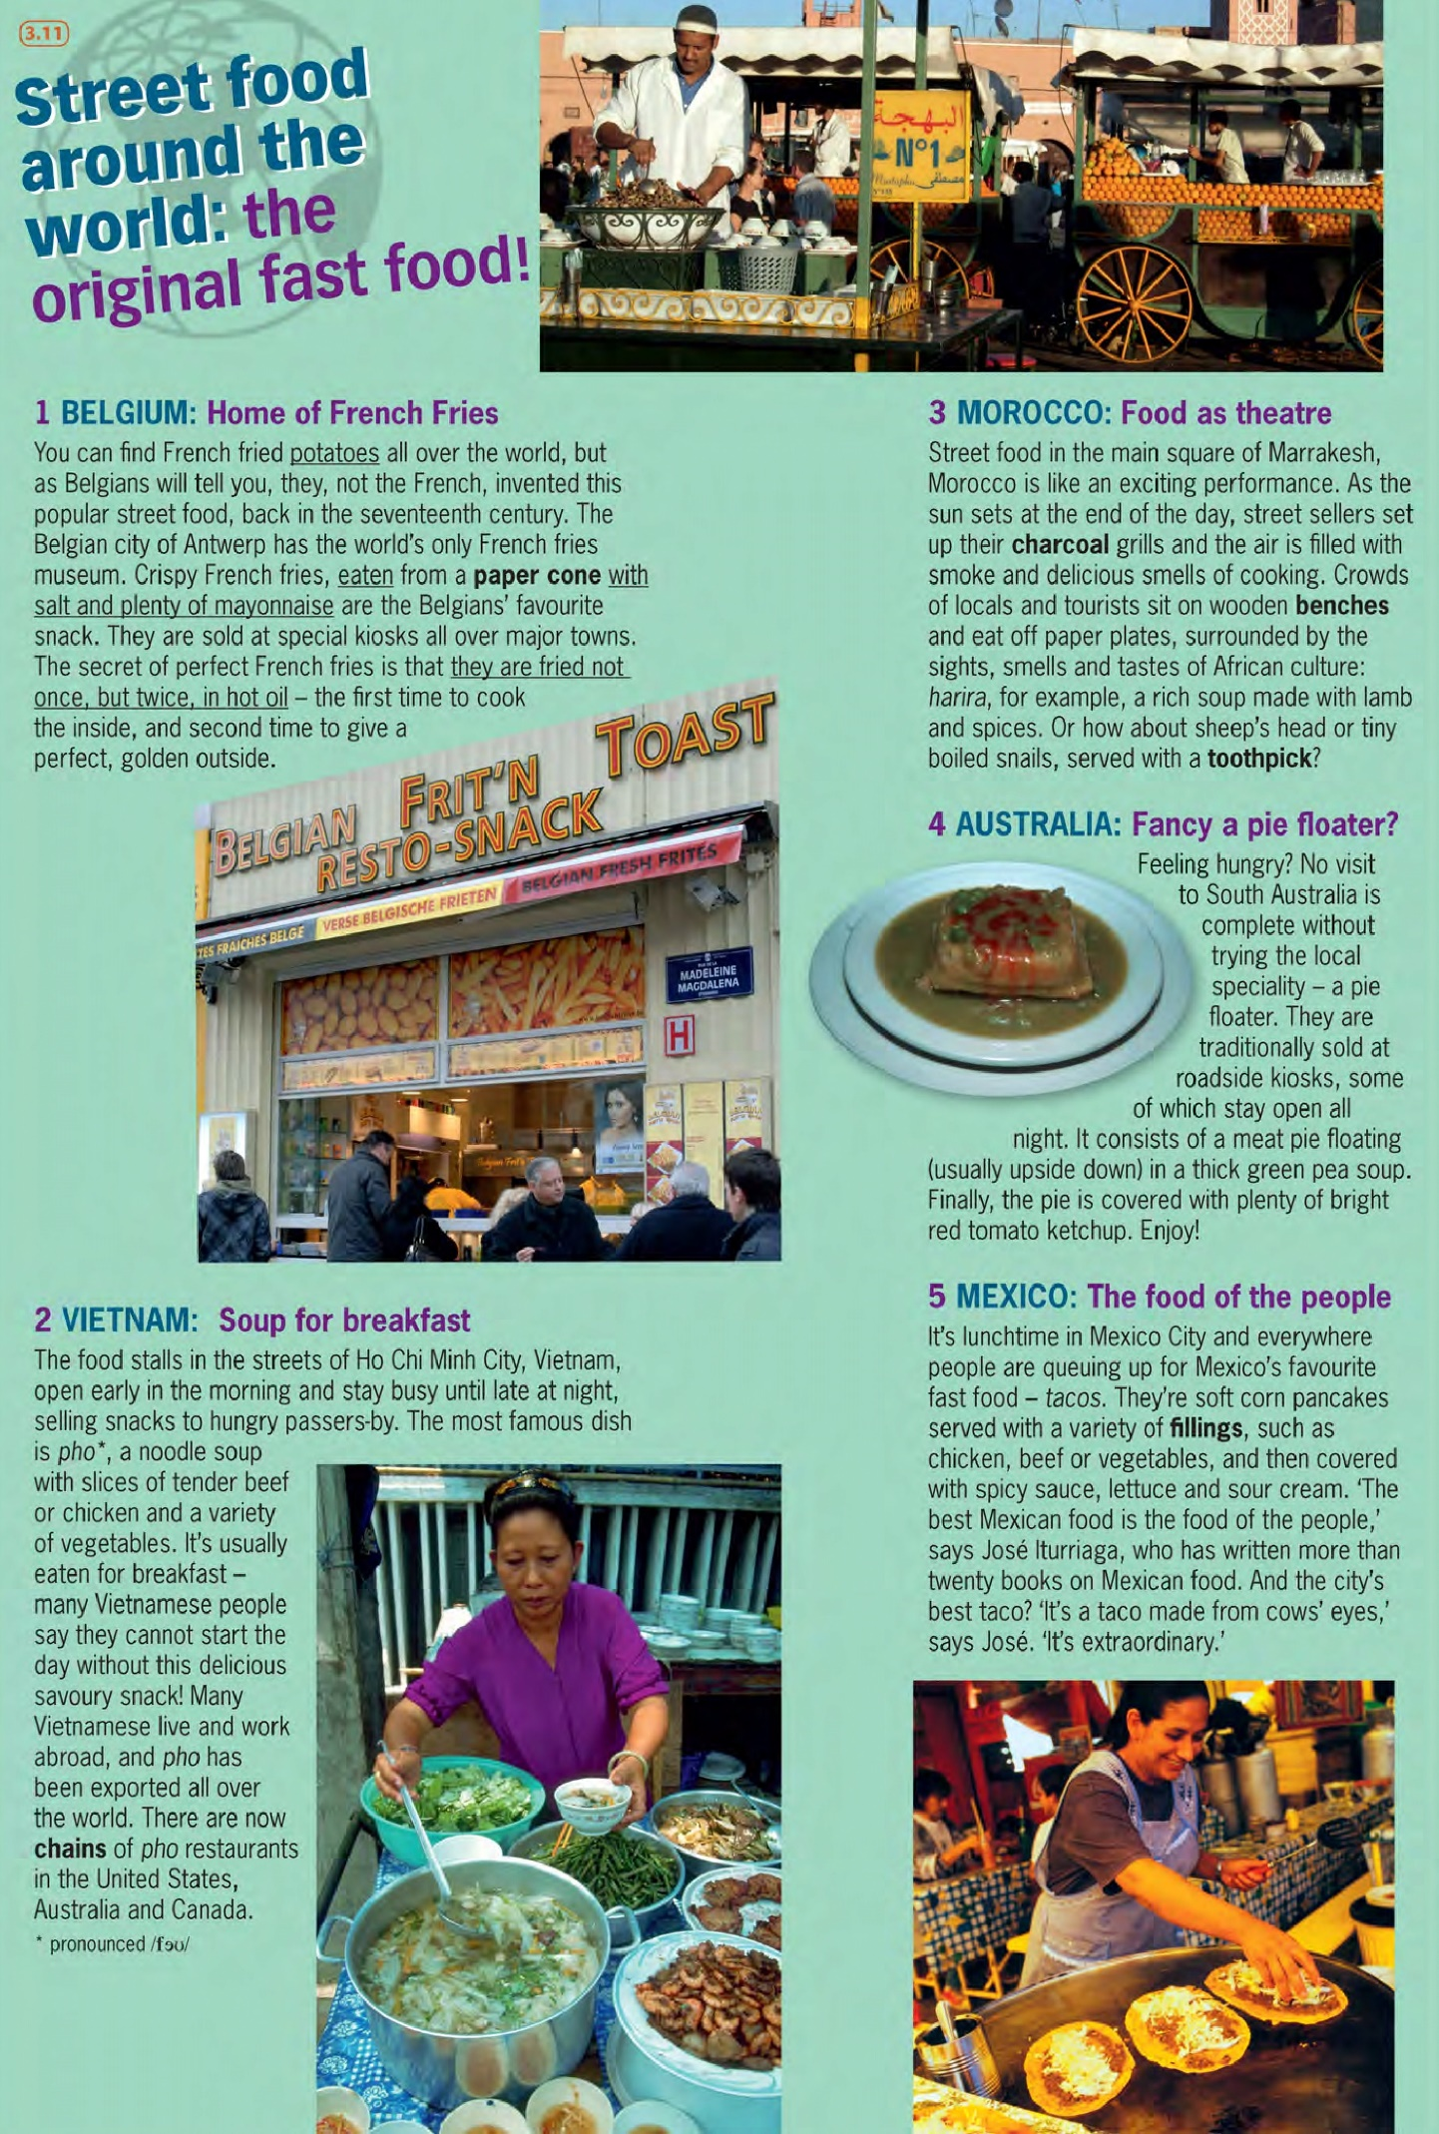
- Read the text and find the ingredients of these snacks, how they are cooked and what they are served with:
French fries – tacos – harira - pie floaters

- Which snack sounds tasty and which sounds disgusting. Give your opinion.

Writing
- Write a paragraph about a typical ‘street food’ in Argentina. Use the following questions as a guide.
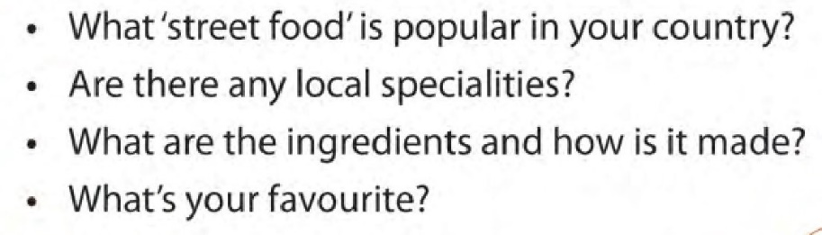
- Write a dialogue between to people A and B. You have to choose a local dish or street snack and discuss. Use the following phrases:
