Read the text and turn the sentences to passive and active as it corresponds.
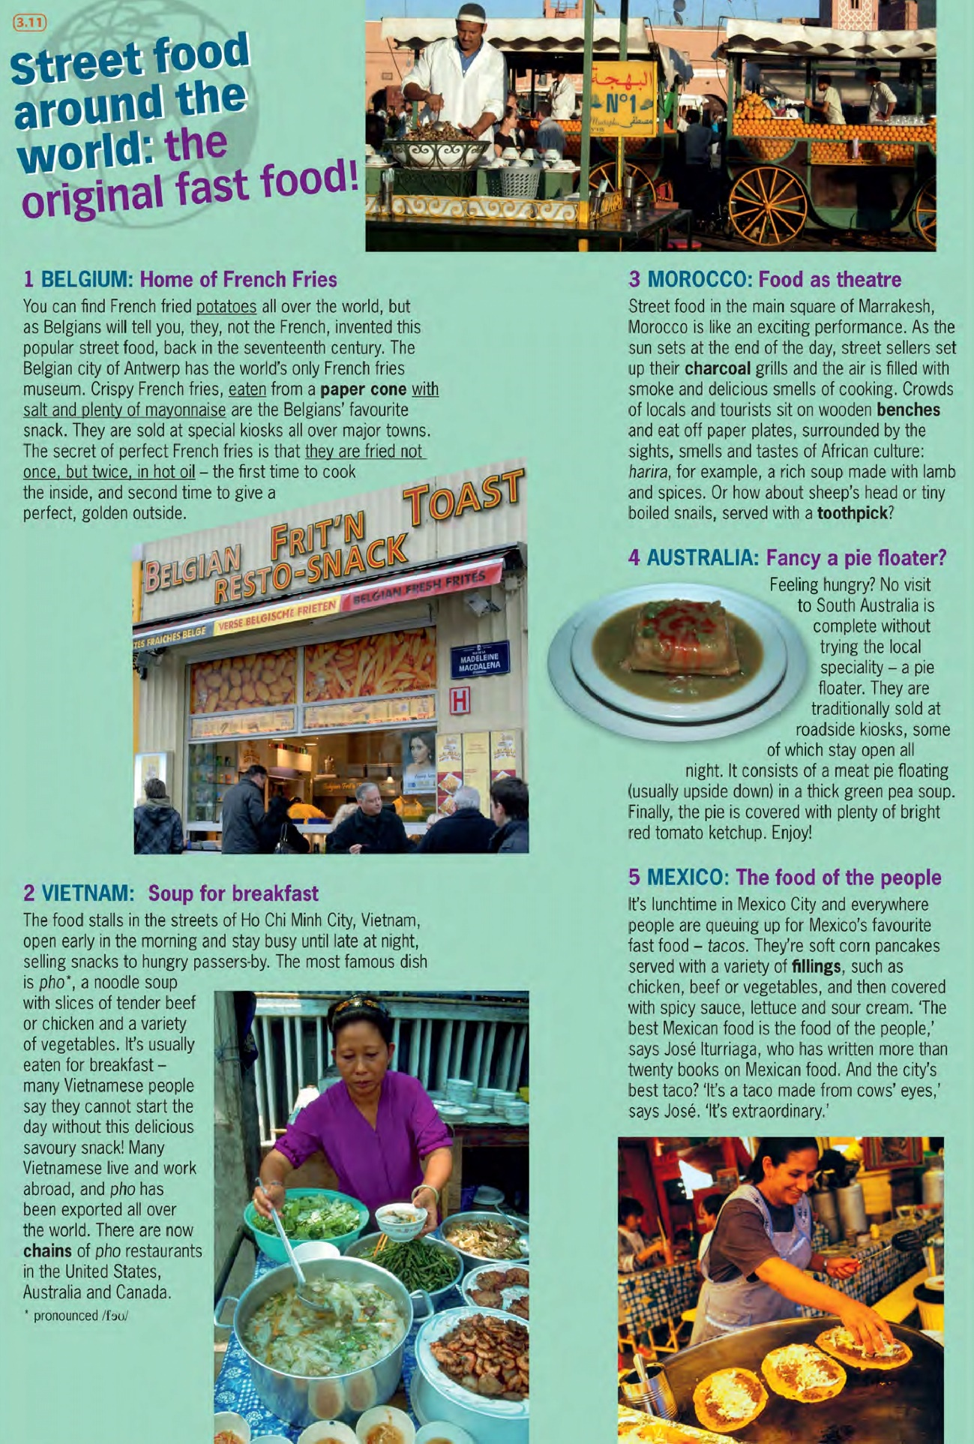

LISTENING
1- Look at the pictures and think about….
- What nationality they are: Argentinian

- Where they live: they live in Colegiales

- What they like eating: toast with cheese and butter, drink mate, the little girls eat cereals with chocolate milk
- How old they are: Milagros is eleven years old and julietta is seven years’ old

- What jobs they do: Roberto work in the reporter for channel nine an Argentinian television network he reports on lots of different stories every day is different to do but he loves his job, Gabriela works at a local radio station and she starts every early. She wakes up before the rest of the family and leaves the house at around 6:30 a.m.

- What they do at weekends: On Saturday they usually get up around 9:00 or 10:00 a.m. and they all make breakfast together. They eat toast with cheese and butter but julietta has cereal with chocolate milk. Roberto and Milagros drink mate a typical Argentinian.
Sometimes Roberto makes special omelettes they´re delicious after breakfast the family often play games sometimes they play board games but the girls often prefer to play video games. In the afternoon they often go for a walk or go to the park near their house, it´s a small park but it has swings and slide so the girls have lots of fun.
Sunday is a relaxing day too in the morning they stay at home, Gabriela reads the paper. Roberto drinks more mate and the girls play on the computer. In the afternoon they usually visit Gabriella’s parents and have a large meal with them they all eat outside they have barbecued meat with salad and bread. After the meal they have coffee and go home.

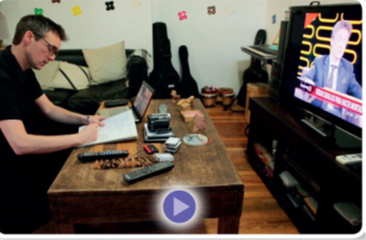
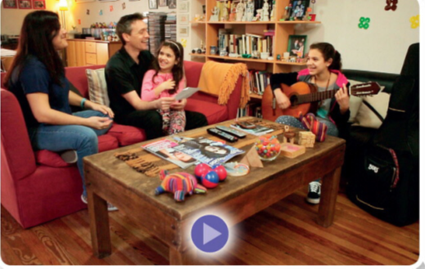

- Watch the video about Menna family and check.
https://www.youtube.com/watch?v=I1aqbMDFOdE

- Watch the video again and choose the right option.

- Roberto works for a television network at home
- Gabriela goes to work at 6.30 a.m.
- Milagros and julietta go to the same school
- The girls get up at 9.00 or 10.00 a.m. on Saturdays
- Gabriela drinks coffee
- After breakfast the girls play video games
- They go to the park in the afternoon before lunch
- The family usually visits the girls ‘grandparents on Sundays
- They eat salad with their barbecue
- On Sundays they go to bed early

