Unit 1: passive voice – have something done
Class Assignment
- Read the article and try to complete each text with the name of the film and country where it was made. Use the photos to help you.

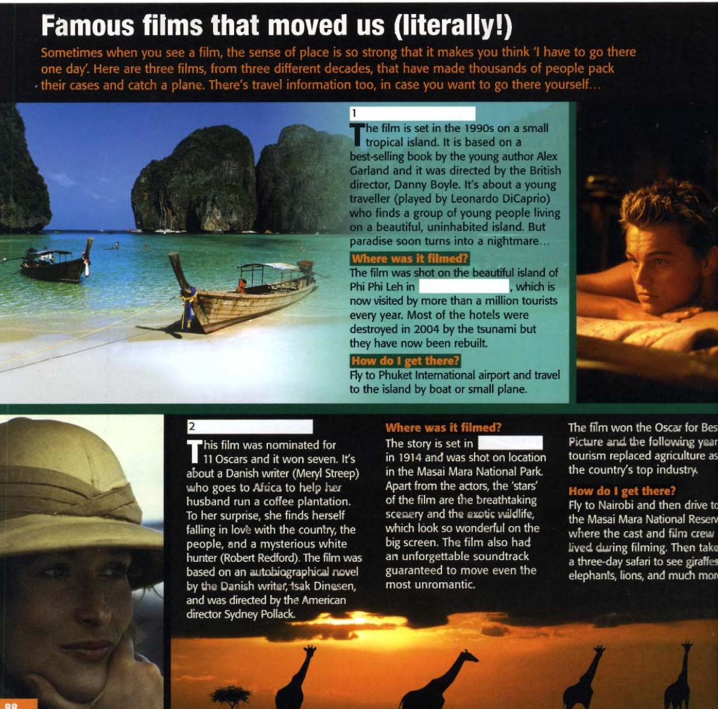

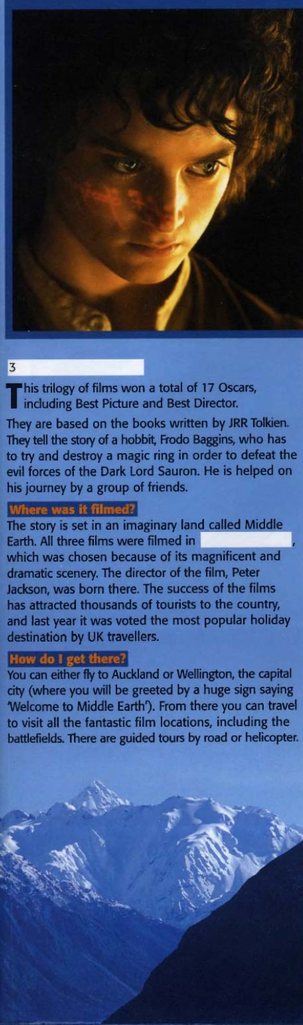
7- VOCABULARY- cinema
A-Try to remember words and phrases from the article, which mean…
- The music from a film the s_________
- The person who makes a film the d_________
- All the actors in a film the c_________
- All the people who make a film the f______ c______
- (filmed) in the real place, not o______ l_______
In a studio
- The part of a cinema or tv the s________
Where the image appears
B- Write a sentence with each of the words from exercise A.
4- Read the article again and look for 10 sentences in the passive and turn them into active.
5- Read the article again and look for 10 sentences in the active and turn them into passive.
6- Choose one paragraph from the article and change it from passive to active and from active to passive as it corresponds.
2- Read the article again and answer the questions:
Which film(s) had…..?
- Had Three parts
- Were based on a book
- Was set at the beginning of the beginning of the 20th century
- was set on a place where later there was a natural disaster
- was filmed in a wildlife park
- didn’t win an Oscar
- was a romantic film
- was directed by a man born in the country where the film was made
3- Answer the following questions:
- have you seen these films? Did you like it or not? Explain why.
8- Read the questionnaire and answer the questions. Then check them with your classmate’s.
