COLEGIO SAN JOSÉ
Ciclo lectivo 2022
Nivel Primario
DATE: MAY 24TH
NAME:_________________________
2° “ ”
- COUNT AND MATCH.
3. READ AND COLOUR.
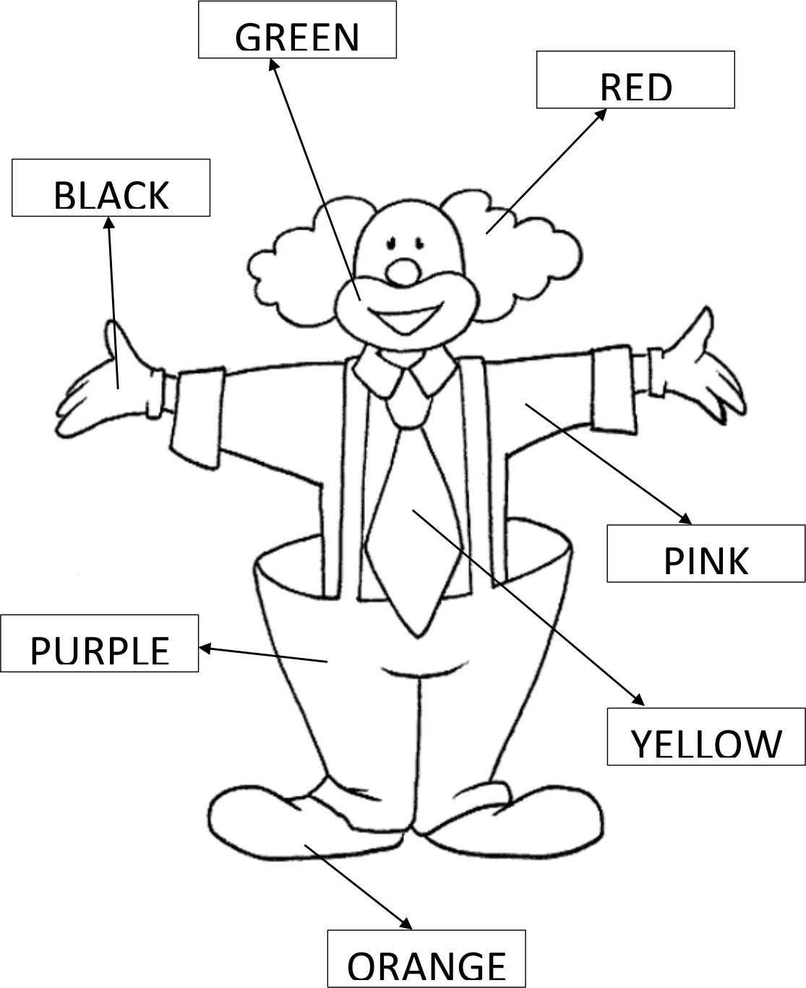
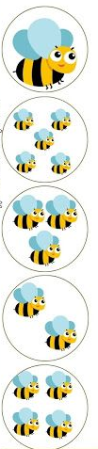
FOUR
THREE
ONE
TWO
FIVE
- COMPLETE.
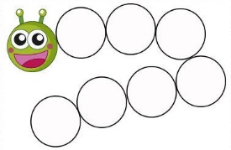
MONDAY
WEDNESDAY
THURSDAY
SATURDAY
FRIDAY- TUESDAY- SUNDAY

