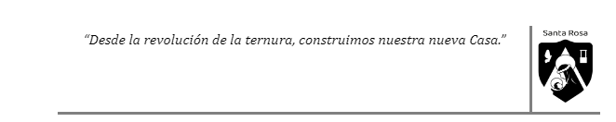

Review Unit 1.
On Tuesday 14th, we are going to divide the class into three groups. Each group should deal with a particular topic as I told you in class.
Group 1: You are going to talk about “Challenges”. Go to page 10. There you have 3 different challenges.
You have to tell all you know about these challenges. If you need it you can look for information on the internet.
These questions can guide you:
- What’s the name of the challenge?
- What do we have to do in this challenge?
- Is there any damage your health can suffer from when doing this challenge? Which one?
Group 2: will deal with Present Tenses. You will have to:
- Go to page 12 and read the study box.
- Read the dialogue and try to find more examples to add to the study box.
Then, you will have to answer:
- When do we use these tenses?
- How do we form sentences when using them?
- Is there any adverb that is particular of each of these tenses?

Group 3: You will deal with Past Tenses.

- Go to page 14 and read the study box.
- Read the text “She did it” and try to find more examples to add to the study box.
Then, you will have to answer:
- When do we use these tenses?
- How do we form sentences when using them?
- Is there any adverb that is particular of each of these tenses?

IMPORTANT: Be ready to explain each of these topics to your partners. We are going to have a debate in class.

