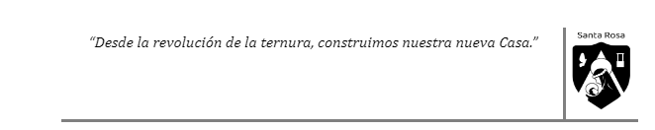
Review Unit 1
For next Tuesday 14 you should:
- Review all the Present and Past tenses we have seen in class and think about the following questions:
- What are the similarities and/or difference between Present and Past tenses?
- When do we use each of these tenses?
- What do I have to remember about each tense?
- What adverbs do we have in each tense?

- Imagine you participated in a 2 week challenge. Talk about it with your best friends/partners and tell them what different challenges you did and how you felt about it.
Note: you can work in groups (no more than 3). Once you finish it you have to give it to me in a different sheet of paper.Remember you should show in this project all you have learnt in this unit.

