Alumna: Milagros Echevarría
Curso: 3°B

"The farewell"
Some time ago I lost someone very important to me, unfortunately I couldn't say goodbye. On February 1, 1820, it was 4 years since I met him, so I decided to go to the place where I saw him for the first time, the forest. It was 05:14 in the afternoon, I was sitting on the same swing as that time, everything was silent, then I closed my eyes and sank into my thoughts.

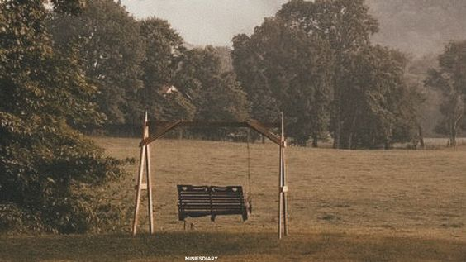

Suddenly I heard his voice:
-Hello how have you been?
I was terrified, I stared at him and sure enough it was him.
Quickly, with tears in my eyes, I hugged him thinking over and over again about what had just happened.
-Let's go! there is no time to cry- he said, he took me by the hand and led me a little deeper into the forest.
-We arrived!
-Wow, I've never seen this, it's beautiful!
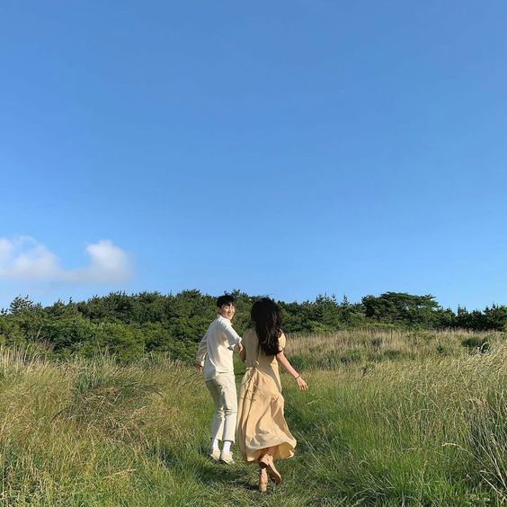
There was a humble house with many flowers and a small black
cat that kept watching us from a wooden fence.

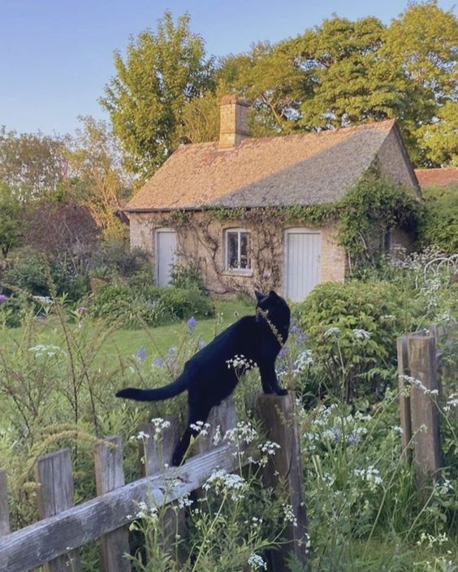

While we explored the house I found several letters, they were mine, I had written them to him a long time ago but I never gave them to him, how did they get here? How does he have them? I thought.
-Oh, I see you found your letters, take this one, it's mine, open it when I leave.
A while passed and we went for a walk, I tried to tell him everything that I couldn't, but just when he was going to do it, he told me:
-Are you going to say goodbye?
Without being able to speak I watched as he began to fade, while the sky darkened and clouded over easily. I couldn't believe what I had just seen and without thinking I ran back to the humble house.
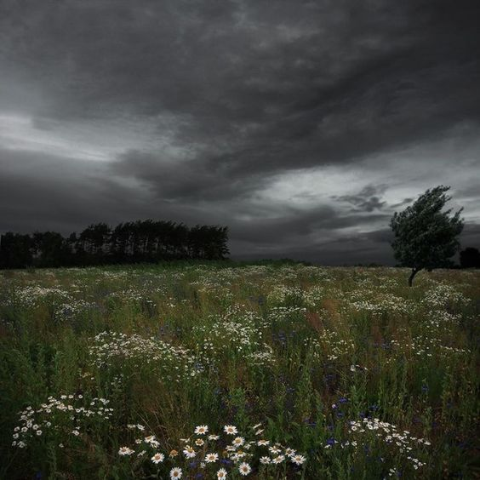

Upon arrival, the black cat was still there on the same wooden fence, only it looked broken and old, the house too, with several tangled plants, it seemed that I was in a dream. But without waiting I read the letter he gave me, it said "Wake up and be happy Sandy", as soon as I finished reading I saw how the cat approached and said "run away".

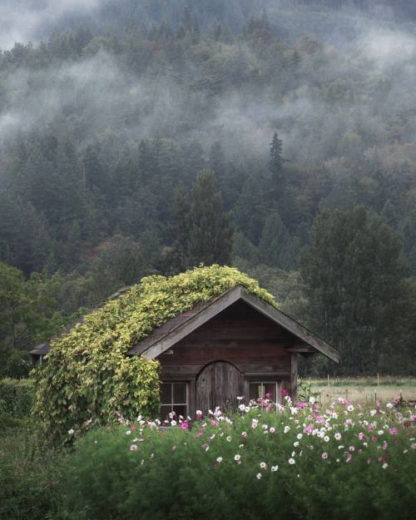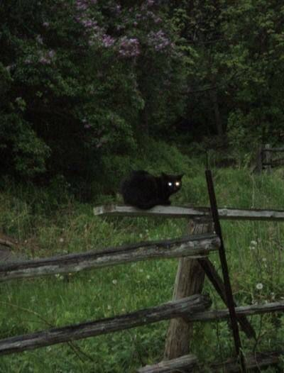
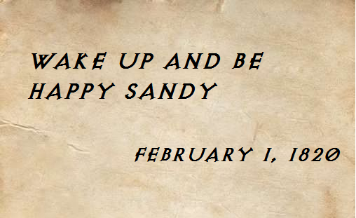

Nothing seemed real, so I didn't hesitate to go back to where I was before so many abnormal things happened, but when I tried to get to the swing there was a big strange door instead, at the same time the forest was falling towards the ground...

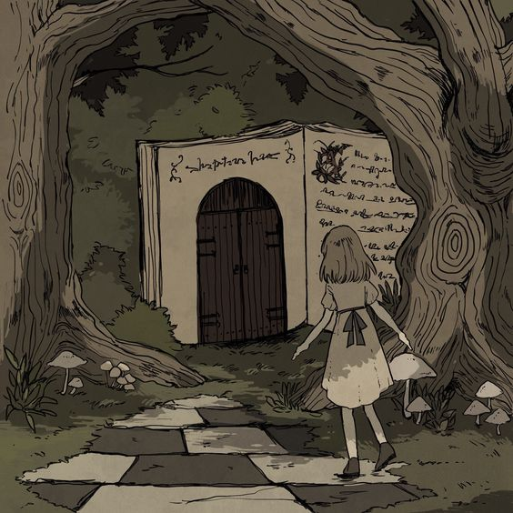

-Sister wake up, wake up! They closed down the forest you used to go to!

