Writing inglés
Delfina Yornet 3B

Once with my mom we wanted to go zip-lining
I climbed on his back and when we were halfway up his hands slipped and he fell
she started crying and we had to go to the emergency hospital and it turned out that she had broken her leg
To all this, my sister was a few months old, I cannot spend much time with my mother and I cannot feed her well, I was just 4 years old
Months passed and my mom had to use crutches to be able to walk better, today with so many changes in weather it hurts a lot.
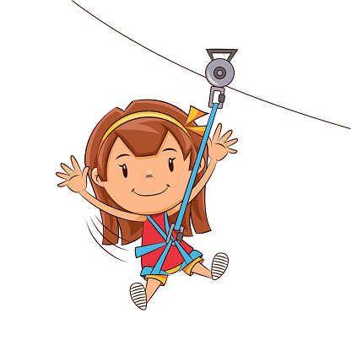
It all happened because of an unexpected misfortune.

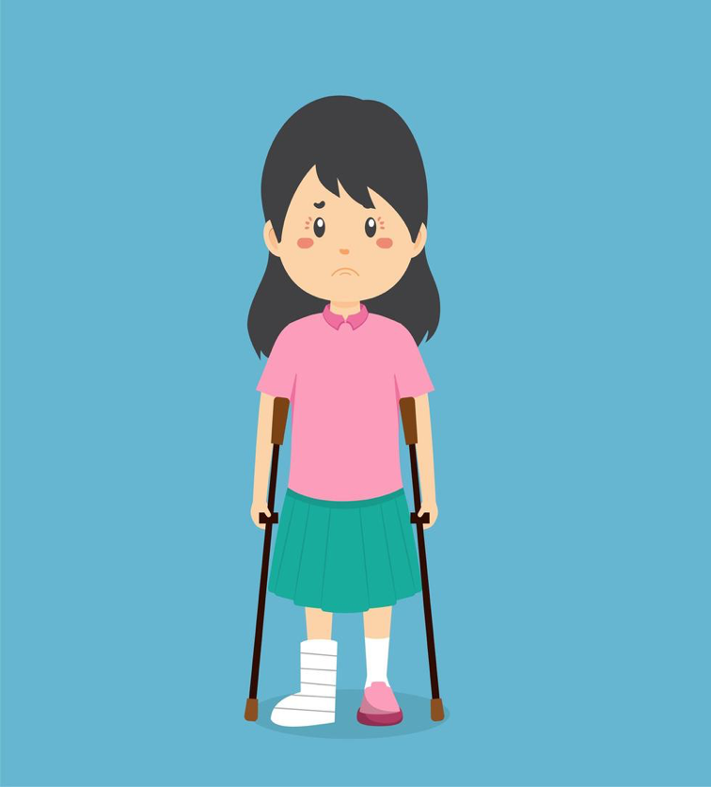
Historia con más de 100 palabras.

