The enchanted emerald
Once upon a time there was a boy who every day, when he returned from school, played in the forest near his house. There he amused himself observing insects with a small magnifying glass, climbing the trees in search of leaves with strange shapes or choosing beautiful flowers to take to his mother.
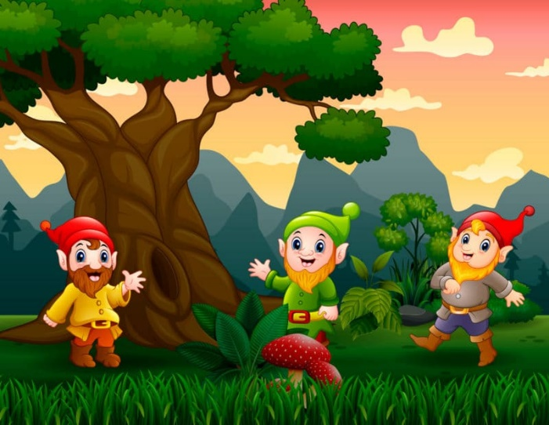
One autumn day, under a tree, he discovered a row of mushrooms and immediately noticed that something was moving on them. When he got closer he saw that on each one there was a goblin. Yes, a goblin!
He rubbed his eyes to check that he wasn't dreaming. No, he was wide awake and the goblins were still there, looking at him with curious eyes and a mischievous smile.
Since they seemed friendly, he began to chat with them and they became very good friends. Since then, every afternoon the little boy returned home as soon as possible, took his snack, and ran to the tree under which those little ones lived, so funny that they told him exciting stories of the forest. He never told his secret!
Months passed and winter came. The snow covered everything and the boy had to stop seeing his dear friends because his parents wouldn't let him go outside to play. It was too cold and he could catch a cold!
One of those cold and windy days, his father asked him to go with him to look for firewood.
– Son, put on your coat, your leather boots and your scarf, we're going to look for some wood. Wrap up well!
They took the forest road and casually stopped by the goblin tree.
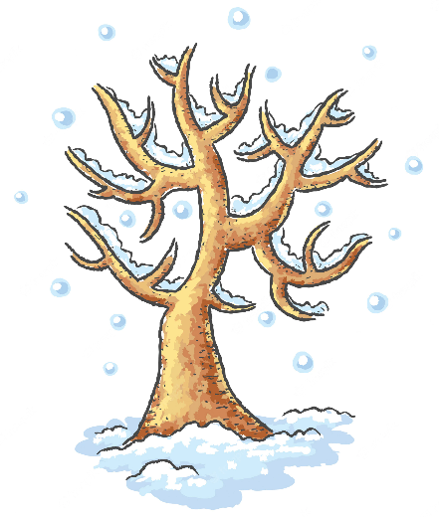
– This tree is perfect!
The boy, horrified, joined the palms of his hands and begged him not to do it.
– Not dad! It's my favorite tree and some friends of mine live here.
The father laughed thinking that his son had too much imagination.
–Are some of your friends living with this tree?… Well, well, that's fine, but on one condition: from now on you'll be the one in charge of collecting a little firewood for the fireplace every day, okay?
– Yes, I promise, I'll take care of it!
The boy breathed a sigh of relief and of course kept his promise. Without showing any laziness, every afternoon after doing his homework he spent some of his time collecting trunks and branches around the house that his mother would later throw on the fire.
One day, finally, the sun's rays began to warm the earth strongly. The snow melted and the songs of the birds were heard again among the trees. Spring had arrived and with it the moment that our protagonist had been waiting for so long! As soon as he finished classes, he crossed the forest at full speed to meet up with his friends, the goblins. There they were all together and smiling waiting for his return.
The older man approached him and said:
– Welcome, friend. We really wanted to see you!
– Me too you! I want to hear new stories!
I am going to tell you one now.
- That good!
– We found out that a friend has worked all winter collecting firewood so that his father would not cut down the tree where we live.
– Eh yes, that friend is me!
The goblin laughed.
–Yes, we know. It is the most beautiful thing that nobody has ever done for us and we want to thank you. You are a wonderful boy and a true friend!
Then he put his right hand in the pocket of his red pants.
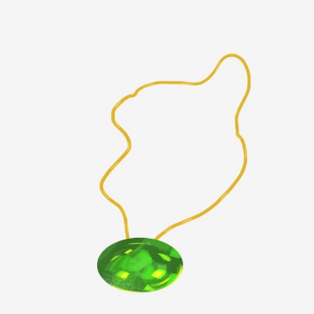
– Take this emerald. Although it looks like a stone like any other, it is a magical stone. If you hang it around your neck and always carry it with you, it will bring you luck and fortune. You will have money, health and love forever.
The boy smiled and obediently put on the emerald tied to a rope as if it were a necklace.
– Thank you, friends, thank you very much. I will never take it off!
– You deserve it for being so good and generous.
The goblins were right! Life smiled on the woodcutter's son and over the years he became a handsome young man, healthy and lucky in love. The stone was lucky! But the most beautiful of all was that he continued to visit his best friends without anyone knowing. It was still his most precious secret!

