Unit 8 – Writing Test
Sofía Graffigna Senior Year

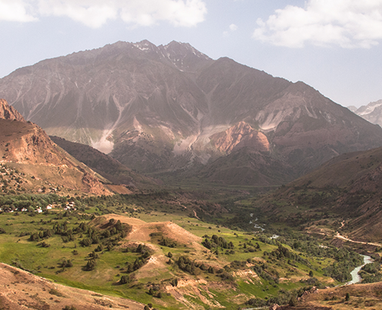
Risky trail
The situation was critical. I was lying at the foot of the mountain and from the pain in my arm I knew that it was badly hurt. Far away from the path I was originally in, I realised how difficult my situation was because people couldn´t see me or even hear me. I had nowhere to go, no way to escape.
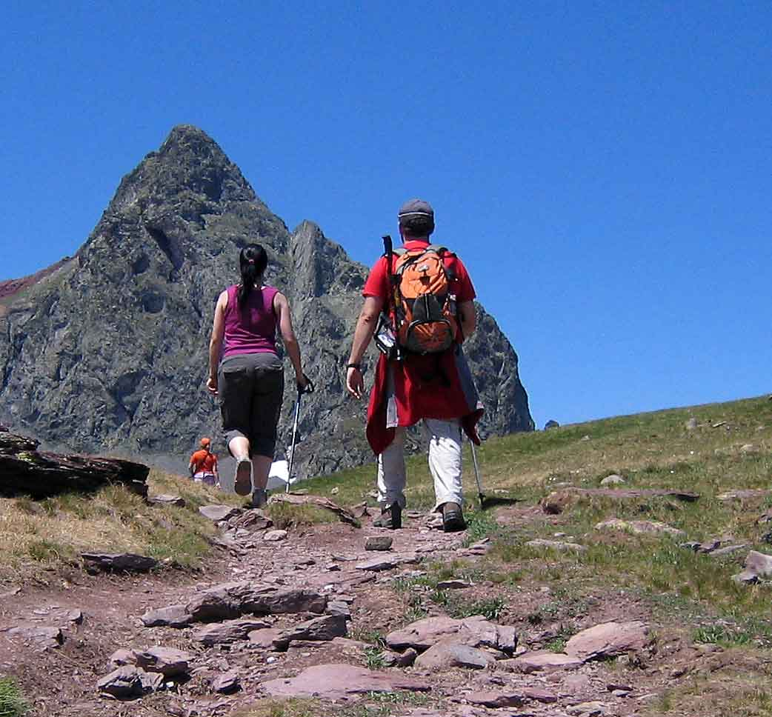
I didn´t blame my hiker partner Alison. She tried to help me but we both would have fallen off the cliff if she wouldn´t have let me go. Despite my injuries, Alison turned around to try to get some help.
The blood had already created a puddle around my arm so I tried to apply a tourniquet to control bleeding. I didn´t have any hope and the pain was unbearable. I shut my eyes and waited silently for the end.
‘Mathew’ cried a voice. ‘Are you there?’
‘Down here’, I called out weakly.
Luckily, Alison had found help and a helicopter took me to the hospital.
When I woke up Alison was there, she told me that next time we choose an easier trail.
It was an experience I will never forget.

