WRITING UNIT 8

In 2020 a woman went on a trip with her children to Chile to spend the summer with her family, on the way there they turned around because of the high speed and the street was very wet from the rain, they were rescued by a food export truck , all were saved but the car could not be fixed. When they arrived in Chile, they had a great time, they visited many beaches and tourist places. the return trip was very good and safe because they returned by plane to avoid inconveniences.
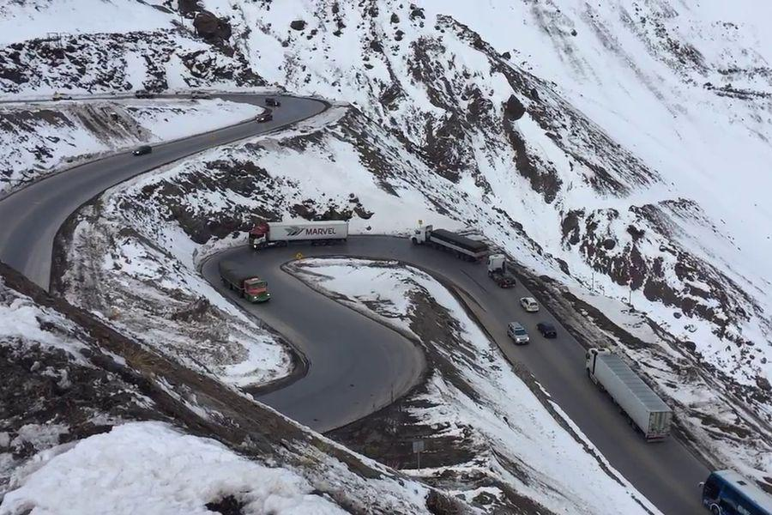

Victoria Cuenca

