COLEGIO SANTA ROSA DE LIMA

“From the Revolution of tenderness, we build our new home”

Name: ________________ Date: _________________
Class: ________
LENGUA EXTRANJERA INGLES-2022
- Look at the following picture and answer:
- How many types of conditional sentences can you see?
- Can you see any similarity and/or difference between them? Which one?
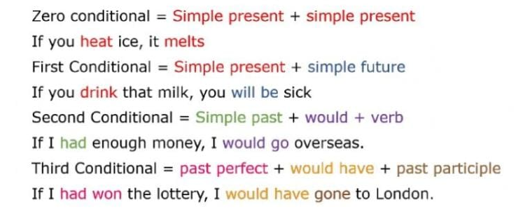
- Match each conditional type with its own use/meaning.

- Zero conditional We use it for imaginary situations.

- First conditional We use it for unreal situations in the past.

- Second conditional We use it for things that are always true.

- Third conditional We use it for things that are probably to happen . in the future.

- First or second conditional? Read the following sentences and choose the correct option.
- Anna would buy this car if she had/ has enough money.
- If my parents had a big house we will/would live all together.
- You will pass all your exams if you start/started studying now.
- If Mark was/is more polite and cheerful he would have more friends.
- We won’t/wouldn’t catch a bus if we go on foot.
- If we don’t/didn’t get there tonight we will have to stay at a hotel.

- Complete the following sentences with Third Conditional.
- If I hadn’t lost my wallet, I ____________ (arrive) at the opera on time.
- Sally wouldn’t have been so upset if she ___________ (pass) the driving test.
- If Tony ____________ (save) some money, he would have travelled to Paris last summer.
- If Lisa ___________ (not/be) so tired, she would have gone to the concert last night.

- Look up on the internet motivational phrases that show different examples of conditional sentences. Then, indicate which type of conditional they belong to.

- Look at the following pictures and write conditional sentences.
