Shirts of those selected for Qatar 2022.
ARGENTINA
headline alternative
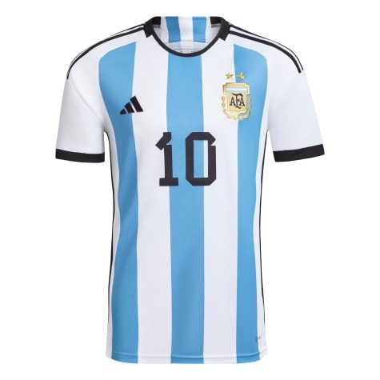
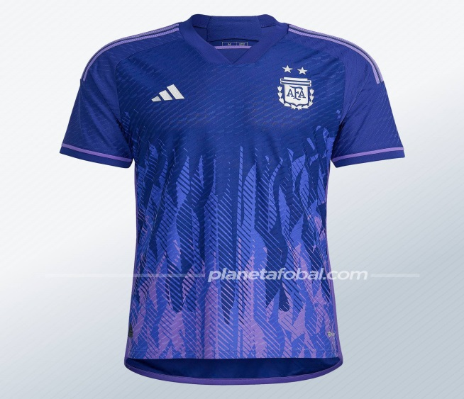
T-shirt design:
Headline: the shirt has three light blue canes on the front with a slight gradient from top to bottom and the details are in black: the sleeve cuffs, the neck, the three stripes and even the Adidas logo. The most distinctive thing is probably on the back, where instead of three sticks like on the front there are two on the sides, and the middle one is actually a kind of flag: light blue, white and light blue bands that go from the top to the bottom. down and with the sun in the highest part of the shirt, at the height of the neck.
Alternative: it has details similar to that of the rays of a sun coming from below, with the presence of the sun of May -one of the most important national symbols- on the nape and silver.

T-shirt meaning:
Headline: With its classic light blue and white colors, the new shirt makes two references to the Argentine flag.
Alternative: Purple has to do specifically with the identity of the feminist movement.
Brand: the brand that makes the clothing for Qatar 2022 is Adidas
MEXICO
Headline alternative
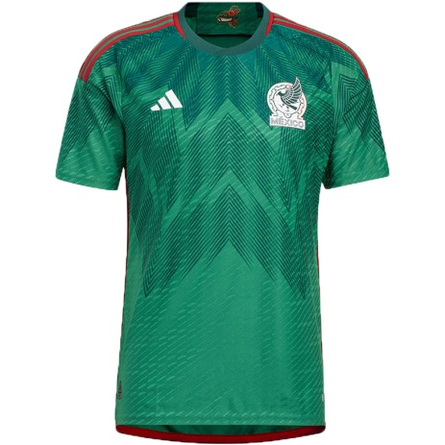
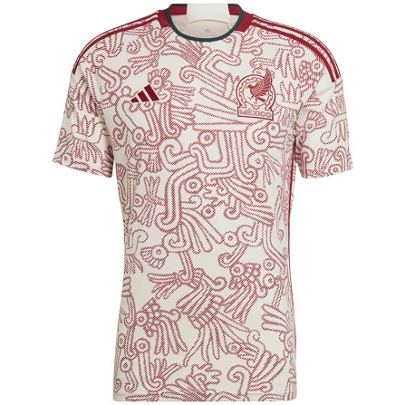
t-shirt design:
Headline: we can see an emerald green shirt with red trim and a mesh on the chest.

Alternative: we can see that it is a white shirt with red drawings all over the front and these have a meaning.

Holder: it is inspired by the country's flag.

Alternative: It is inspired by the "abundant graphic elements of the pre-Hispanic collective memory of Mexico" and represents the "indigenous roots" of the country.
Brand: Adidas.

Saudi arabia
headline alternative
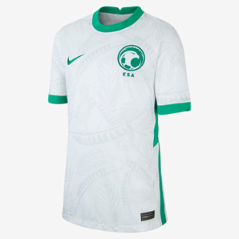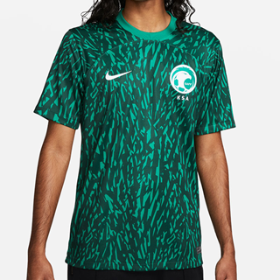

T-shirt design:
Headline: we can see that the shirt has a white chest and has gray designs. The ends of the sleeve are green, as is the neck, and the national team's shield and the brand's logo can be seen.

Alternative: we can see that the t-shirt has a dark green color as a base and on its base it has a fantasy color in light green and the collar also has a small one in the same color.
Headline: It is inspired by the country's flag.
Alternative: does not have a symbolic meaning.
Nike brand.
Poland:
Headline Alternative
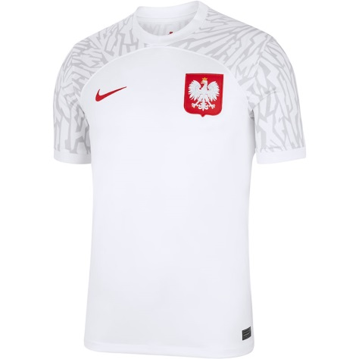

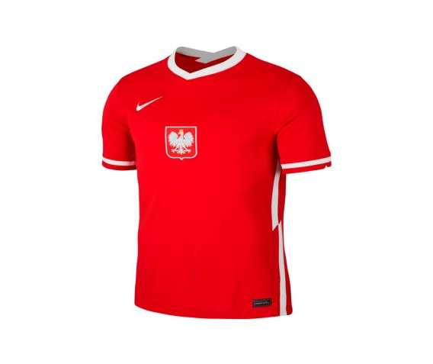
T-shirt design:
Holder: the shirt is all white and on the sleeves it has gray designs and on one part of the chest it has the country's coat of arms, on the other part it has the logo of the brand that designs it.
Alternative: the shirt is all red and in the middle of the chest it has the coat of arms of the country and a little higher is the logo of the brand that designs it and on the side of the torso, on the neck and on the ends of the sleeves it is colored white.
Headline: It is inspired by the colors of the country's flags.
Alternative: it does not have a special meaning or is inspired by something.
Nike brand.

France
Headline alternative
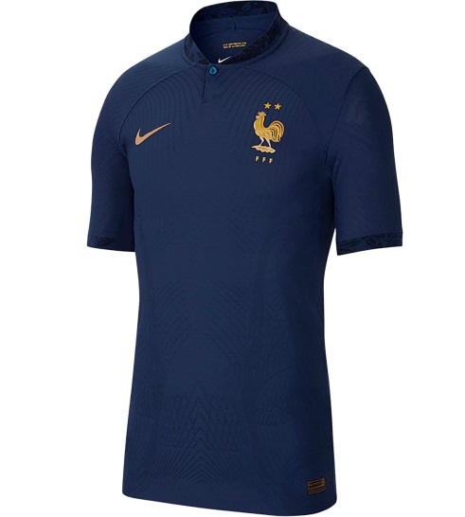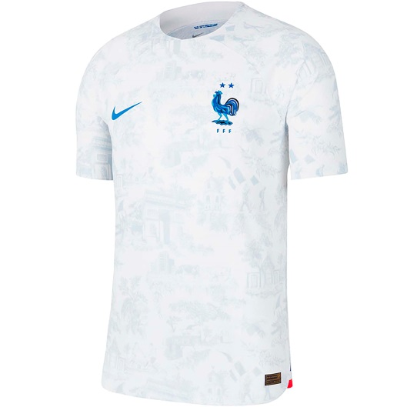
T-shirt design:
Headline: it is a dark blue shirt with no details, totally plain, only the national team shield and the logo of the brand that makes it can be seen.
Alternative: this shirt is white and on it there are drawings representing the country in a very light gray tone and the shield on one part of the chest and the brand's logo on the other part.
Holder: it is blue because the country's flag contains blue and represents the country.
Alternative: it should be noted that the two shirts are designed under the theme our differences make us the same.
Nike brand

Australia
Healdline Alternative
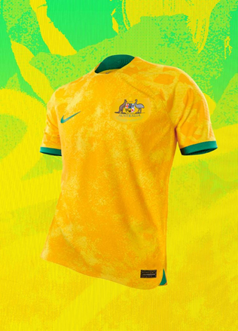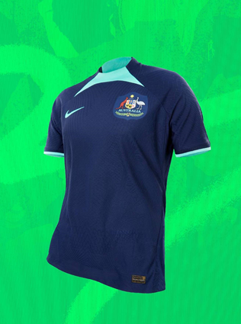
T-shirt design:
Holder: we can see that the base is a yellow color and above the base it has orange spots, the tips of the sleeves are green.
Alternative: this is blue and has a light blue color on the chest and the sleeves are also light blue.
Holder: does not have a specific meaning because they represent the colors of its flag.
Alternative: it does not have a special meaning.
Nike brand.
Dinamark

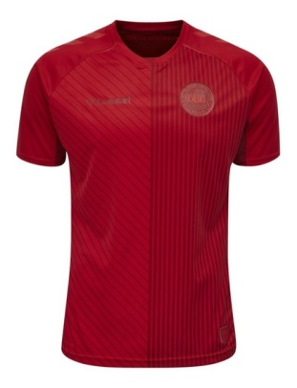
Headline alternative
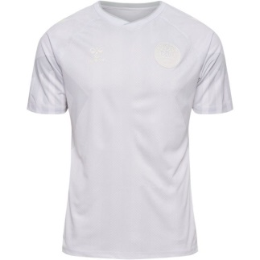
T-shirt design:
Headline: we can see that this shirt is completely red with vertical and diagonal lines and the shield on one side and the logo on the other.
Alternative: we can see that the shirt is totally white and on one side is the shield and on the other side the logo.
Headline: represents the colors of the flag and being completely smooth is a sign of protest against the host country and recalls a design with which the country won the Euro 94.
Alternative: and the alternative has totally the same meaning
Brand: hummel
Tunisia
Headline alternative
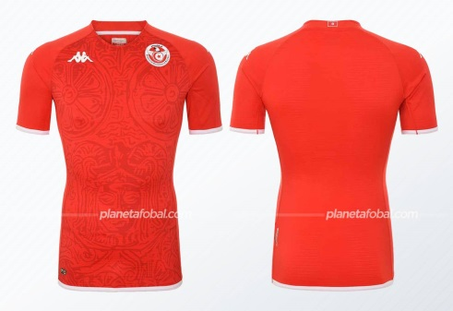
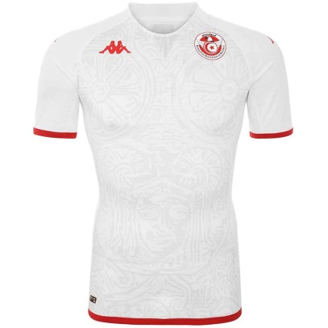
T-shirt design:
Headline: This jersey has a red base and has graphic designs on it.
Alternative: it is totally the same but with different colors and here the sleeves and the tip of the shirt show details in red.
Headline: Front graphic shows a Punic cuirass found in Tunis 1909.
Alternative: has totally the same meaning.
Brand: kappa.

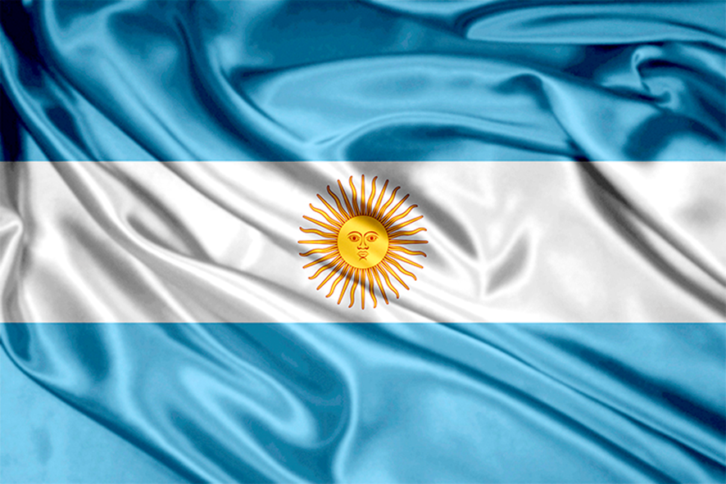

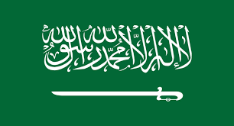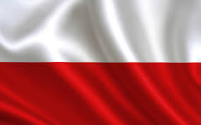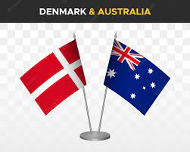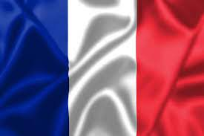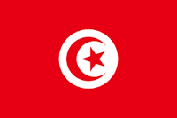

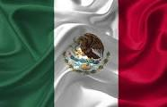
Lautaro
Octavio
Guilled
Agustin
Abril
Tiziana
Ana

