Part 1: Infinitives of purpose
Answer:
-What do you use a laptop/ a memory stick / for?
Part 2: Comparatives and superlatives
e.g. Make comparative and superlative sentences
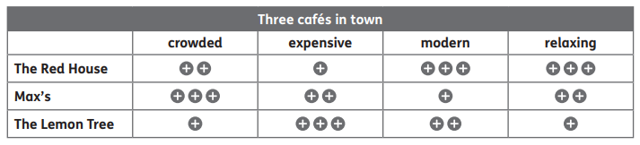
Who is the (tallest) in your family?
Who is the most/ least …(boring)…………………….in your family?
Who is the best/ worst football player in your opinion?

Part 3: Past Continuous + prepositions
Look at the pictures and find the differences using PAST CONTINUOUS AND PREPOSITIONs
e.g. In picture This girl was (dancing) In Picture B she was…………………………………
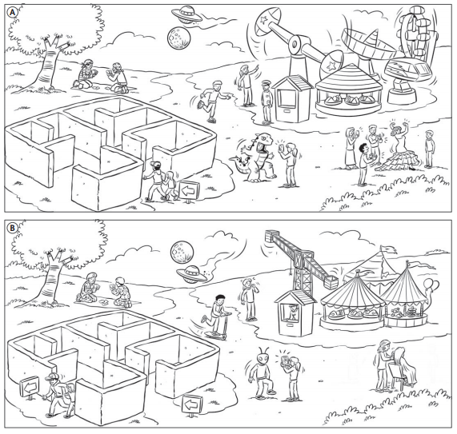
POSSIBLE QUESTIONS FOR PREPOSITIONS: above/ below/ through/ inside/ …(Unit 5)
- Where are the man and the girl in the maze in both pictures?
- Where is the security guard in both pictures?
- Where is the moon and the spaceship n both pictures? Which is above and which is below?
- Where are the balloons in picture b?

Part 4: Must-Need to
Complete the rules about a school trip:
Arrive on time - wear a school uniform – take photos – use your mobile phone – run because it’s dangerous – listen to your teacher – sit in the waiting room – bring your lunch and a drink – do your homework

Part 5: (Pair work) Will
- Describe the picture using will and won’t
- Look at the picture and ask each other questions about what the people will do
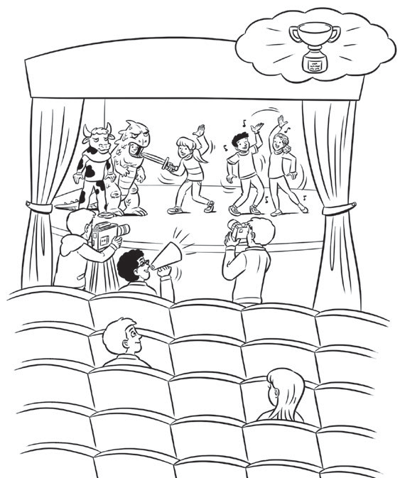

What will you be in the future?

