Introduce yourself
My name is………….
I’m …….. years old.
I go to …………………………..school.
I (play….. /do…../ go …..) at school.
My favourite (sport/ animal/….) is………………………

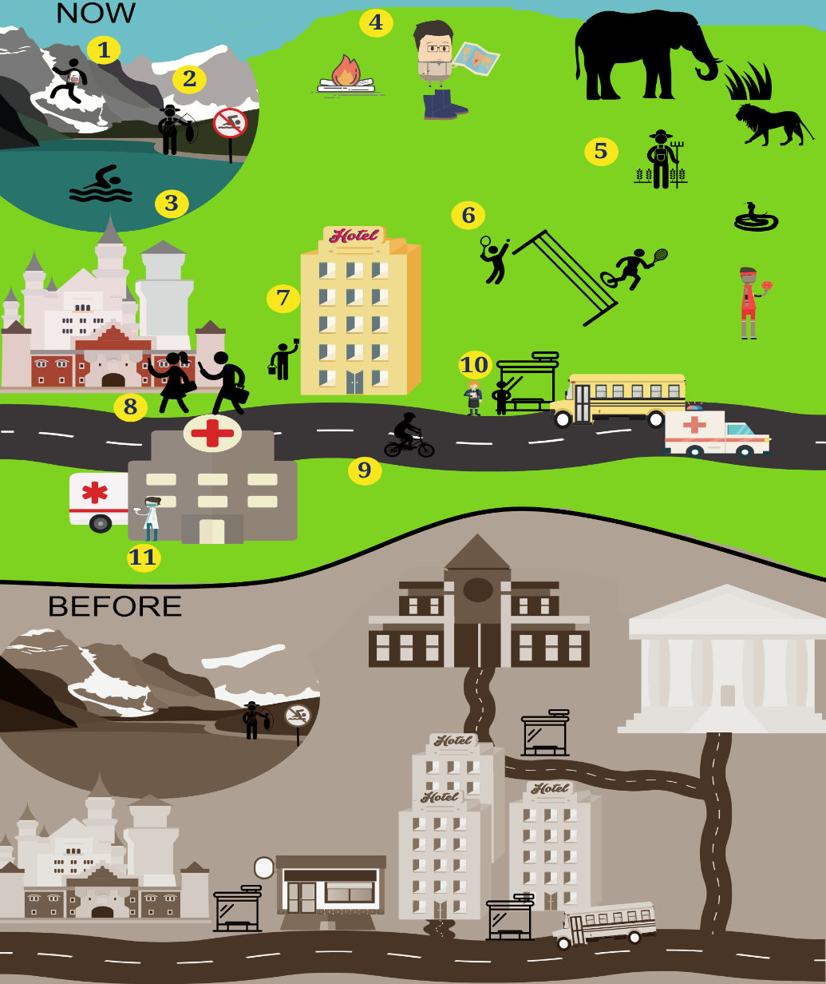
Possible Questions for the speaking based on pictures

- What are the people doing? Playing badminton, going abseiling, ….
- Is there anybody (playing basketball)? Ѵ Yes, there is. / ꭓ No, there isn’t.
- Is he/she abseiling or climbing? Ѵ Yes, he/she is. - / ꭓ No, he/she isn’t.
- Are they playing table. Tennis? Ѵ Yes, they are. / ꭓ No, they aren’t
- Compare the animals in the picture
- Which is the tallest/smallest/fastest/Slowest animal in the picture?
- Is the (Lion) bigger/smaller/taller/shorter/longer than the (snake)?
- Is the hospital near/opposite/next to the hotel?
- Is the castle next to the bus station?
- Where is the hotel/hospital/bus station?
- Tell me about the buildings now and before.

e.g.: Now, there is … There are…. There isn’t… There aren’t ….
Before there was… there wasn’t…. There were… There weren’t…

- What are the people in 8 going to do? They’re going to…
- How many/Which jobs can you identify?
- How many buildings are there? There are three/ four/ five buildings.

- What is he/she doing? e.g. He/she is (going climbing)
- Is he/she a scientist or a cook?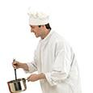

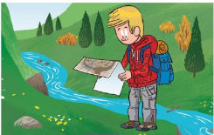
- Did he look at the map? Ѵ Yes, he did. / ꭓ No, he didn’t.

- Did he/she have a (wool hat)? Ѵ Yes, he did. / ꭓ No, he didn’t.

- Is he wearing a cotton t-shirt? What is he wearing? He is wearing….

- Did he take a rucksack? /climb a mountain? Ѵ Yes, he did. / ꭓ No, he didn’t.

- Is there any campfire? What can you do there?
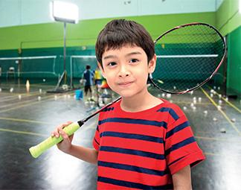

20) Why is the boy/the girl happy? Because he/she is ...

21)- Are the people scared?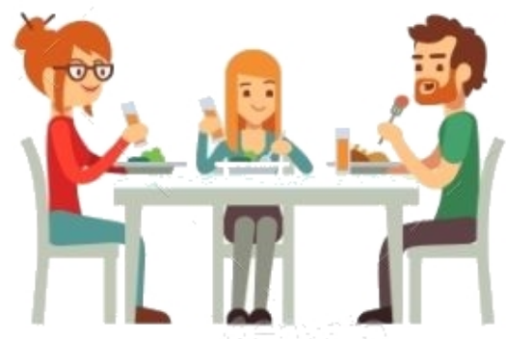

22)- Is there any glass bottle / plastic car / (wooden/metal) object?
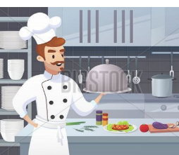
23)- Where’s the cook? Is he in the museum? Where is he?

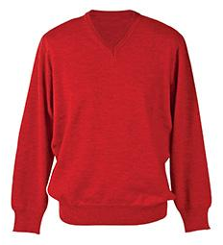
25)- Is it a cotton t-shirt? What is it?

- What are the people in 8 going to do? They’re going to…

Possible Personal questions

1- Do you practise any sports? Ѵ Yes, I do. / ꭓ No, I don’t.
2 - Which sport do you practise?
3 - Who is the (tallest/ youngest/) person in your family?
4 - Who is (taller) your granddad or your father?
5- What did you do yesterday/last weekend? What didn’t? - I visited… /I went to…/ I played...
- I didn’t make… / I didn’t eat….
6 - What are you going to do next weekend/ Next summer holidays?

Next weekend / Next summer holidays I’m going to……

