1- Read and complete the text with the words in the box

Was- won- do- Why- went – met- best- friendly-
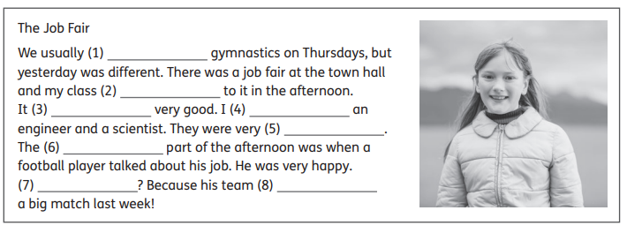
2- Read again and answer the questions

1- What do they usually do on Thursdays?

2- Was there a job fair at the school?

3- When did they go to the job fair, in the morning or in the afternoon?

4- Did she meet an artist?

5- Who did she meet?

6- What did the football player talk about?

7- Was the football player nervous?

8- How was he? Why?

