

COLEGIO SANTA ROSA DE LIMA

“From the Revolution of tenderness, we build our new home”

Name:

Emilia Girini
Date:

Class:

5to b

UNIT 3

- Look at the picture and write their corresponding names. You can read the “Vocabulary A box” to help you.
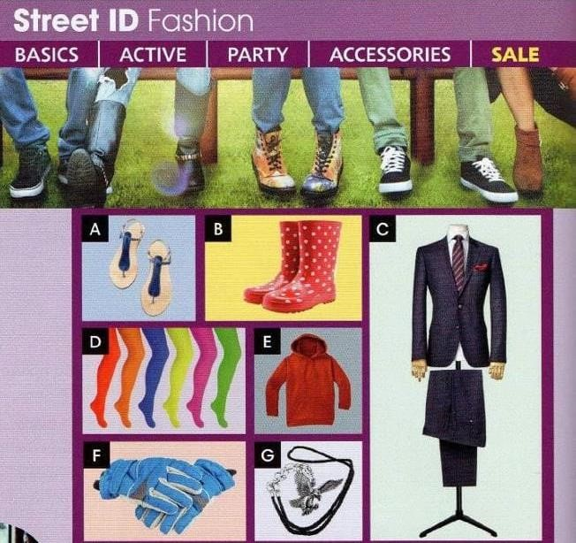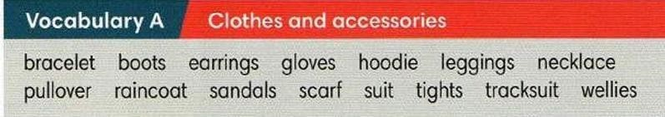

- Sandals
- boots
- Suit
- Leggings
- Raincoat
- Gloves
- Necklace

- Choose one of the previous words to complete the following sentences.
  - These keep your hands warm in winter. gloves
  - You need these on your feet in the countryside when it’s raining.
wellies
  - Men wear them on particular/special occasions. suit
  - These are tights and you wear them on your legs. leggings
  - You use it when you do sports. hoodie

- Read the Vocabulary A box again and answer the questions:
  - What types of clothes do you like the most?
I like leggings.
  - What do you usually wear at home?
I wasually wear t-shirts
  - What does your mother/father usually wear when she/he do sports?
They wear hoodies

- Look at the following picture, read the examples on it and guess the different forms/structures of this tense. Then answer:
  - What’s the name of this tense?
Present perfect continous tense
  - When do we use it?
We use it to emphasize suration or repetition
  - What’s the similarity and/or difference between this tense and Present Perfect simple? You can go to page 120 and read the two boxes that appear on it.
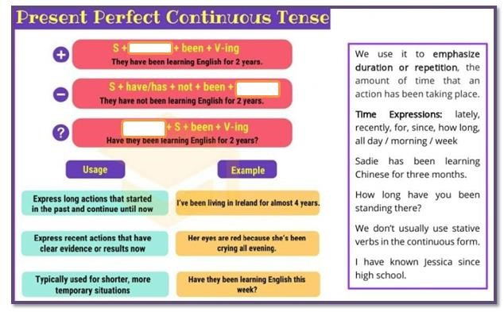

- Read the text and complete the missing parts with Present Perfect Continuous.

I never used to be interested in my appearance, but recently I ____have wear____ (wear) more fashionable clothes. It all started a few weeks ago, when my friend Jana saw me at school and said, “Kate, you ______has come_____ (come) to school in the same clothes for ages now! Let’s go shopping together.” I agreed because she was right- I
____don´t shop______ (not/shop) for clothes since last year and I really needed some new things.
Now I’m really into fashion and I ______have write_______ (write) a blog about a new style for

the last six months. People tell me they __has enjoy_____ (enjoy) it and I get messages from people all over the world. One person asked me “How long ___do___ you _______has write______ (write) the blog?” and couldn’t believe it when I told her only six months.

- Use the prompts to write sentences. Add what you need to make complete sentences.
  - how long/ study/ you/ fashion? How long you study fashion?
  - Mark and Jill/ for hours/ heavy metal/ listen. Mark and jill listen heavy metal for hours.
  - for hours / walk round the shops/ Julia. Julia walk round the shops for hours
  - em/ not practise/ much recently/ the piano em much recently not practice the piano

- Complete the following sentences with your own words.
  - I have been riding a bike
  - My mother hasn’t _cooking pizza________ she has been ___taking a shower_.
  - My favourite actress/singer has been ____Gerard Way__________.

