

COLEGIO SANTA ROSA DE LIMA

“From the Revolution of tenderness, we build our new home”

Name:

________________
Date:

_________________

Class:

________

UNIT 3

- Look at the picture and write their corresponding names. You can read the “Vocabulary A box” to help you.
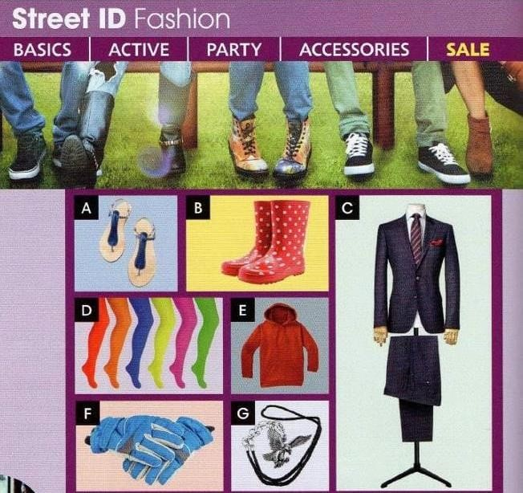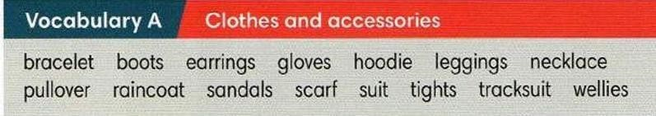

A: Sandals
B: Boots
C: Suit
D:Leggings
E: Hoodie
F: Gloves
G: Bracelets

- Choose one of the previous words to complete the following sentences.
  - These keep your hands warm in winter. GLOVES
  - You need these on your feet in the countryside when it’s raining.
BOOTS
  - Men wear them on particular/special occasions. SUITS
  - These are tights and you wear them on your legs. THIGHTS
  - You use it when you do sports PULLOVER

- Read the Vocabulary A box again and answer the questions:
  - What types of clothes do you like the most?
i like hoodies
  - What do you usually wear at home?
  - I usually wear pajamas
  - What does your mother/father usually wear when she/he do sports?
  - They usually wear shoes

- Look at the following picture, read the examples on it and guess the different forms/structures of this tense. Then answer: a. What’s the name of this tense?
  - When do we use it?
a tense which is used to indicate an action that began in the past and has lasted or continued until the present moment. It uses the auxiliary verb i.e. has been or have been + present participle.
  - What’s the similarity and/or difference between this tense and Present Perfect simple? You can go to page 120 and read the two boxes that appear on it.
The present perfect continuous can be used to emphasise the length of time that has passed. The present perfect simple is generally neutral: They've been waiting for hours!
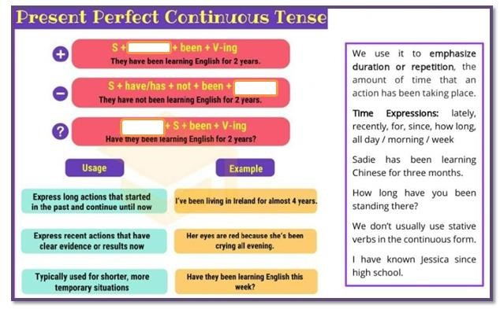

- Read the text and complete the missing parts with Present Perfect Continuous.

I never used to be interested in my appearance, but recently I ___been wearing____ (wear) more fashionable clothes. It all started a few weeks ago, when my friend Jana saw me at school and said, “Kate, you __________coming________ (come) to school in the same clothes for ages now! Let’s go shopping together.” I agreed because she was right- I
_____have not shop___ (not/shop) for clothes since last year and I really needed some new things.
Now I’m really into fashion and I _____been writing______________ (write) a blog about a new style for

the last six months. People tell me they ___enjoying______ (enjoy) it and I get messages from people all over the world. One person asked me “How long ___has___ you ___been writing_________ (write) the blog?” and couldn’t believe it when I told her only six months.

- Use the prompts to write sentences. Add what you need to make complete sentences.
  - how long/ study/ you/ fashion? ___How long you study fashion?
  - Mark and Jill/ for hours/ heavy metal/ listen. __Mark and Jill listen heavy metal for hours
  - for hours / walk round the shops/ Julia. ___ Julia walk round the shop for hours
  - em/ not practise/ much recently/ the piano. ___em not practice much recently the piano

- Complete the following sentences with your own words.
  - I have been studying a lot
  - My mother hasn’t _been singing___________ she has been _dancing______.
  - My favourite actress/singer has been ___lana del rey____.

