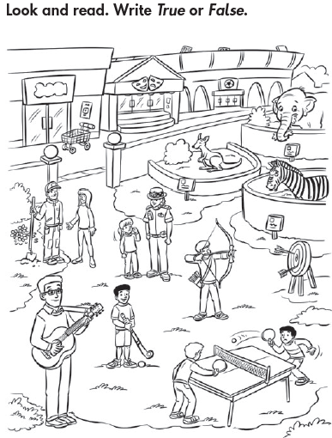

1- There are 2 girls. The youngest is talking to the police officer. __________
2- There’s a museum between the supermarket and the stadium._____________
3- The gardener is talking to the oldest girl. _______
4. The happiest boy in the pictures is the table- tennis player.________
5- The zebra is smaller than the kangaroo. _________
6- The tallest person in the picture is the musician.__________
2- Read and complete the text with the words in the box

