COLEGIO SANTA ROSA DE LIMA

“From the Revolution of tenderness, we build our new home”

Name: ________________ Date: _________________
Class: _______
LENGUA EXTRANJERA INGLES MOCK EXAM - 2023
Final Mark____/76=_______
READING
- Read the text and answer the following questions. (3 marks)
- What ideas to protect the environment does the text mention?
- What did China do to avoid pollution?
- Why are mushrooms important?
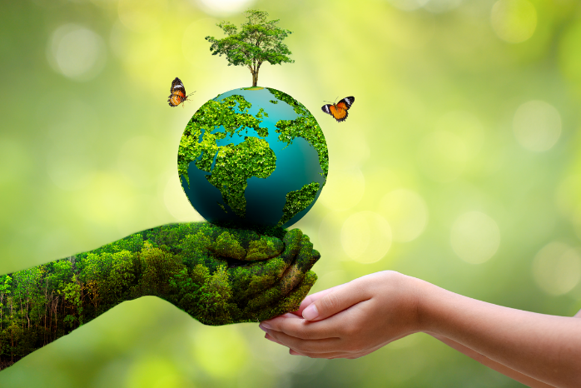
There have been many ideas for ways to protect the environment, but not all of them have proved to be successful and some have even damaged the environment in ways that the creators had not considered.
One idea, floating cities, is something that many people hope will solve the problem of overcrowding in our cities. This has been tried in Dubai, but it seems that the man-made islands have damaged the ecosystem. A project in China has been a little more successful by producing pollution-free islands, but they are far too expensive to copy around the world.
Another idea to save the planet was to use biofuels instead of traditional fuels. They’re made from natural oils from plants such as oil palm or soybean and are therefore a renewable form of energy. However, they have severely damaged the environment by causing deforestation in some places and creating a global food crisis as farmers use the land for producing biofuel and not food. In addition, biofuel production also requires a lot of water, which may mean that local people lose their water supply.
However, for every disaster story there is also a success story. When ships carrying large amounts of oil have accidents, the oil can seriously damage the environment and wildlife. One success story is the discovery that mushrooms can be used to remove all the bad chemicals from the ground.
Another good story is about plastic bags, which we used to get for free whenever we bought something in a shop. In the UK, for example, since they started charging 5p for every plastic bag, the use of bags has been reduced by 85%, which is amazing. It’s such a simple idea but if every country does this, then our land and oceans could be much cleaner. Did you know that 8 million tons of plastic, much of which is plastic bags, goes into the world’s oceans every year and is eaten by many sea animals?
Despite the failures, it’s still important to come up with new ideas that will protect the environment, but we should look at the consequences more closely before putting them into practice.

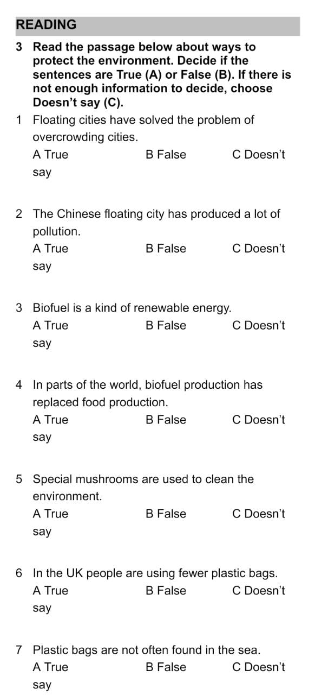
- Read the passage below about ways to protect the environment. Decide if the sentences are True, False. If there is not enough information to decide, choose doesn’t say. (7 marks)

WRITING (15 marks)
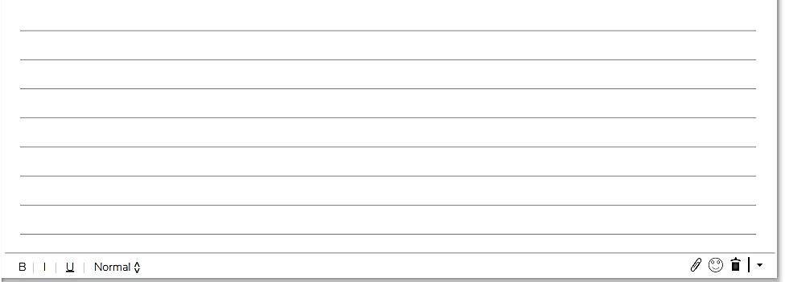
- Write about the importance of be greener in San Juan.

USE OF ENGLISH
- Complete the text with a word from the box. (6 marks)
Community-encourage-factory-join-litter-rubbish

Everywhere I look, there is pollution of some kind. Last night there was a festival in town and this morning there’s so much _________ everywhere. I don’t know why people can’t put their ____________ in the red bins. I’m organizing a big event to make the local ____________ aware of the problem and I want as many people as possible to ____________ my campaign to ____________ people to clean up the town. One good thing is that the big ____________ that produced plastic cartons has now closed so there’s no more smoke going into the air above the town. We just need to make the streets cleaner.
- Choose the correct option to complete the sentences. (10 marks)

Gareth is my best friend. He has / is / fits very good looking and is fourteen. He’s got short blond hair, which is dyed / pale / painted because his natural color is dark brown. He’s got beautiful blue eyes and a dark complexion / freckle / hair. There is a freckle / piercing / collar in his right ear where he wears a silver necklace / bracelet / earring. He doesn’t wear any other glasses / bracelet / jewelry. He usually wears jeans and a hoodie / pullover / jacket, because he likes to hide his face from people. Today he’s wearing a pair of pierced / tired / worn-out black leather gloves / boots / tights on his feet. In fact, they are so old that they have holes in the pockets / laces / soles so his feet get very wet when it rains.

- Read and complete the text with the correct form of “Used to”. (7 marks)
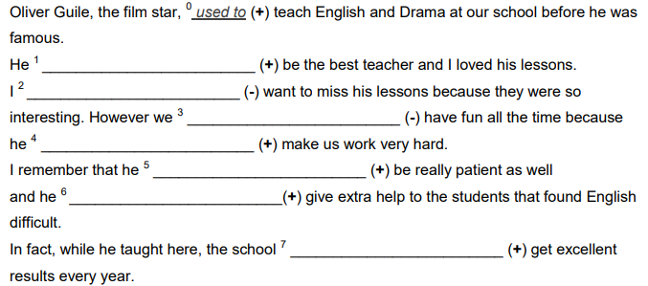

- Complete the text with the correct form of the verb in brackets. (8 marks)
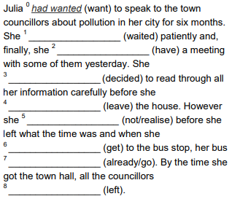

- Complete the sentences with the Present Perfect Continuous form of the verbs in brackets. (7 marks)
- I __________________ (look) for my laptop all this morning. I can’t find it anywhere!
- She _________________ (listen) the same song for an hour. She must really like it.
- _______ you ________________ (watch) TV all evening?
- We _________________ (call) him all day but he hasn’t answered his phone.
- Sam ______________ (not/live) here for three years now.
- Where are you Gemma? Paul _______________ (wait) for you for hours!

LISTENING
- You will hear short four dialogues. Listen and decide if the statements are True (T) or False (F). (6 marks)
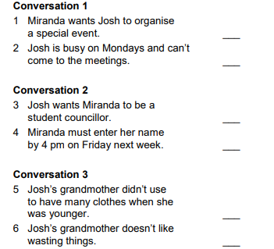

SPEAKING (7 marks)
- Talk about things that damage the environment. What can we do to protect it?
- Talk about pollution in San Juan. Mention the different types and provide examples.
- Talk about the video of Greta and Monbiot: climate change. What was the purpose of the video? What does Greta mention at the end of the video? Compare it with the text of the teen activist.
- Talk about how San Juan used to be a few years ago.
- Talk about how fashion style has changed in the last decades.
- Answer personal questions.

Comprehension | /20
Fluency | /15
Vocabulary | /15
Structure | /20
 | 70%-7 marks

