ESPACIO CURRICULAR: INGLES TÉCNICO III
DOCENTE: Natalia Leotta CURSO: 6° año DIVISIÓN: Economía
TÍTULO DE LA PROPUESTA: GUÍA N°1: “ORGANIZACIÓN DE LAS EMPRESAS”

ACTIVIDADES PRIMERA SEMANA

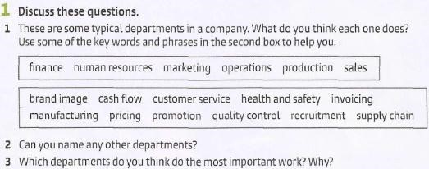

- What do the words in the box mean? Complete the sentences using the words and phrases in the box.
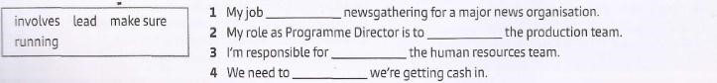
- Look at some expressions people use to talk about their jobs. Complete the expressions in bold using the prepositions in the box.
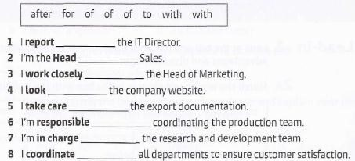

- Read how two people at a news organisation describe their hobs. Complete the texts using words from exercises 2 and 3. Use one word in each gap.
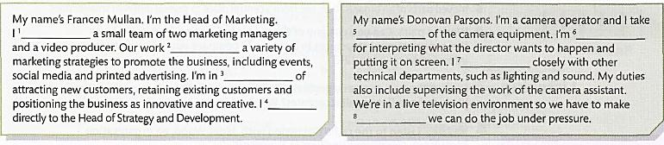

ACTIVIDADES SEGUNDA SEMANA
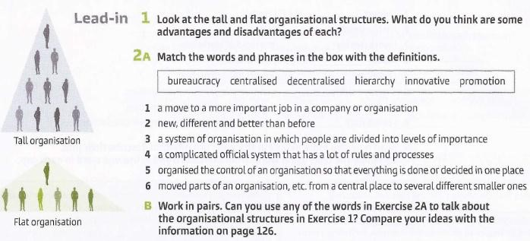

3 Read the following text about tall and flat organisations. Complete the chart.
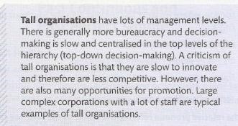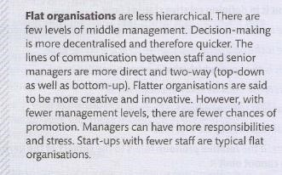

 | TALL ORGANISATIONS | FLAT ORGANISATIONS
Levels
Decisionmaking
Disadvantage
Advantage
Example

