THE GREETINGS  H_LL_! G_ _DBY_!  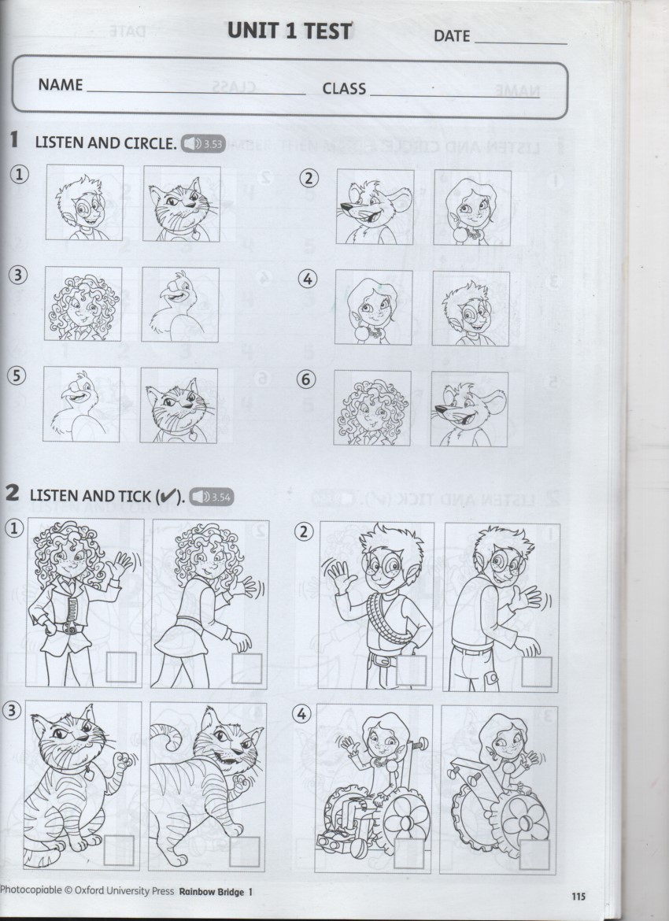 | THE GREETINGS  H_LL_! G_ _DBY_!
THE GREETINGS  H_LL_! G_ _DBY_! | THE GREETINGS  H_LL_! G_ _DBY_!

