“A normal day that ended up being very chaotic”

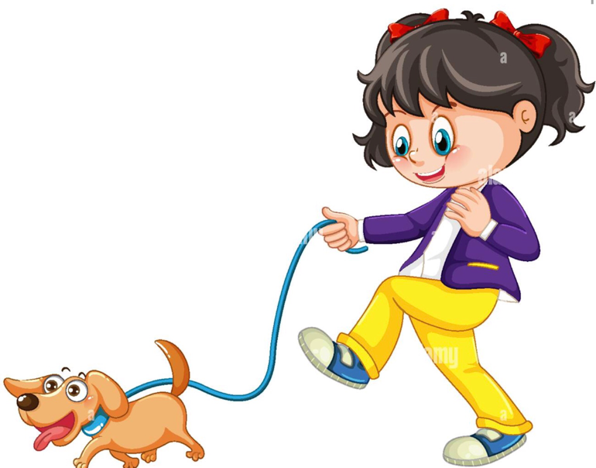


Once upon a time, on an ordinary day in the life of Mateo. He walked with his dog Max around the square, like every day. He was walking very calmly and he met a very pretty girl who was walking with her dog. They were talking for a while, they met and agreed to meet again in that same place the next day.



The next day Mateo changed, had breakfast, prepared Max and left. I arrive at the square and Emma was not there. After a while, Esprando arrived and Max ran towards Emma's dog and scared her, she was very scared that she ran away, Emma ran to look for her, very angry with Mateo for what Max had done. She came back with her dog, and Max attacked her, threw her and hurt her, she was very angry more than she already was, she left, without letting Mateo apologize. Mateo felt very bad, everything had gone extremely wrong, he didn't know what had happened to Max, he never did those things. Mateo returned home very sad because he didn't even have her phone number to call her and apologize. From
that day they never saw each other again

since Emma went to live in Spain.

THE END
Delfina Suarez

