SOFIA BARRIOS
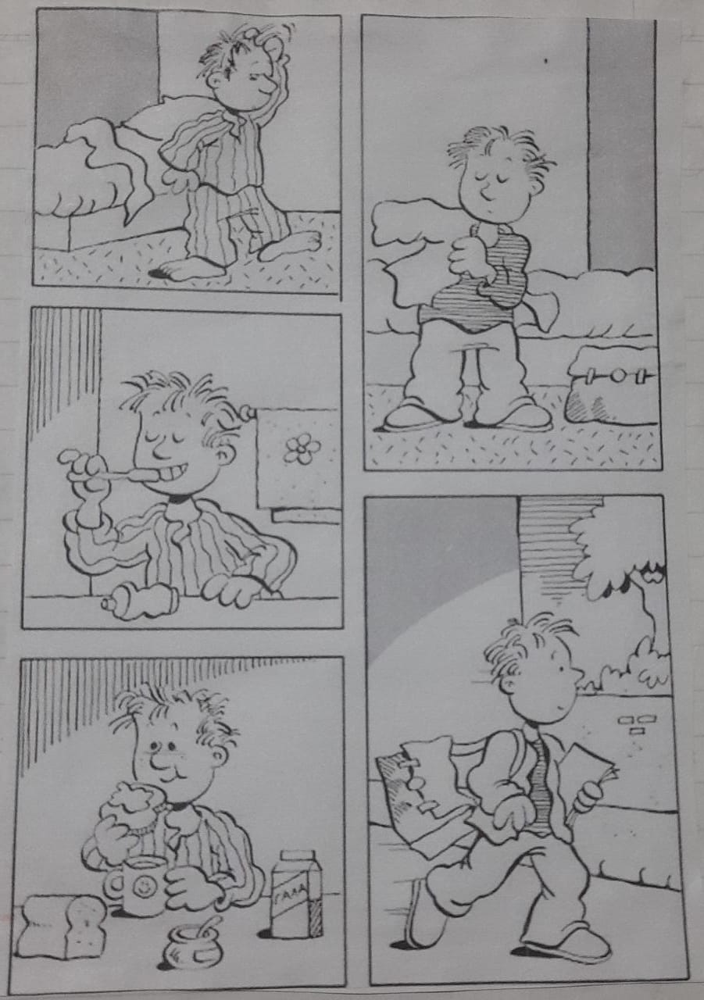
“LA VIDA DE TOM”

IT WAS AN ORDINARY DAY IN TOM´S LIFE, WHICH BEGAN BY GETTING OUT OF OF BED VERY DAY EARLY. HE WAS VERY TIRED, SINCE THE NIGHT BEFORE HE HAD SLEPT LATE STUDYING FOR A MATH EXAM. HE TOOK OUT HIS UNIFORM AND BEGAN TO CHANGE SO AS NOT TO BE LATE. THEN, HE WENT TO THE BATHROOM TO WASH HIS FACE, TEETH AND COMB HIS HAIR. AFTER THIS, HEWENT TO THE KITCHEN TO PREPARE A COFFE WITH SOME TOAST FOR BREAKFAST, WHILE HE REVIEWED FOR HIS EXAM. WHEN HE FINISHED EATING BREAKFAST, HE WASHED HIS CUP AND PLATE AND TIDIED UP THE KITCHEN AS HE ALWAYS DID TO HELP HIS MOTHER. HE WENT TO HIS ROOM, ORDERED HIS BACKPACK ACCORDING TO THE MATERIALS HE HAD DURING THE DAY, LOOKED FOR A COAT AND LEFT HIS HOUSE. HE WAS WALKING, SINCE THE SCHOOL WAS VERY CLOSE TO HIS HOUSE AND ON THE WAY HE MET HIS FRIENDS. UPON ARRIVING AT SCHOOL, THEY WEN TO THE KIOSK UNTIL IT WAS TIME TO TAKE THEIR EXAM

