GEORGE THE MONKEY


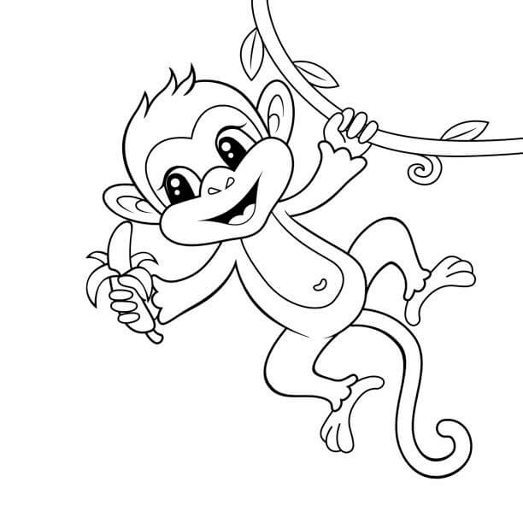
Once upon a time there was a boy named Lucas who went on an excursion with his classmates and friends to the savannah. They went to visit the jungle and Lucas got lost so he started walking walking until he got hungry and in one of the palm trees he found a banana. up in a palm tree he grabbed it and when he opened it he heard a noise he looked back and was surprised because he saw a little monkeyThe little monkey wanted Lucas to share his banana and Lucas gave him a little and suddenly Lucas realized that he had eaten everything and he didn't leave anything for Lucas But Lucas didn't care so much and the monkey for having eaten his banana, the monkey guided him to a camp that had also come on an excursion and that was nearby. and they took him to lucas with his companions and he told them everything that had happened to him and they all started laughing at the little monkey. cuando volvieron de excusion le conto a sus padres lo que le habia pasado y les dijo que para su cumpleaños le regalaran un monito. When his birthday arrived, he opened his present and realized what he had been given. A little monkey and he remembered the little monkey that he had found in the savannah and decided to name him Jorgito. And that was how Jorgito and Lucas became great friends and the story of Jorgito and Lucas en ded

