ISCHIGUALASTO
Ischigualasto is the Provincial Park of Valle Fertil, also called Valle de la Luna, it is located in the northwest of Argentina. Open from 8am to 5pm every day.
It is made up of 5 stations.
- Painted valley: you can see three different colors in the mountains, and the landscape is very beautiful
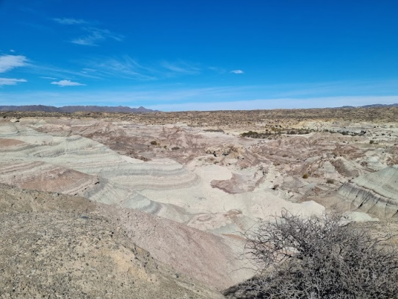
- Bocce court: They are made of iron, more and more are being found, and they had to put up the railing because the people who were going kicked them and they broke.
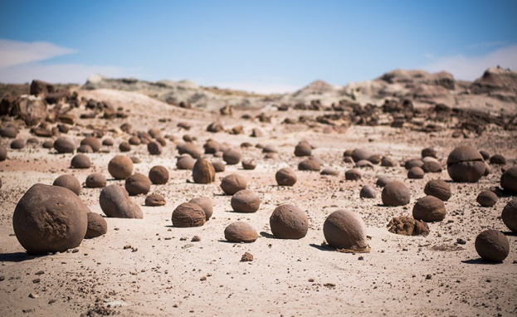

- The submarine: one of the towers of the submarine collapsed due to a strong Zonda wind
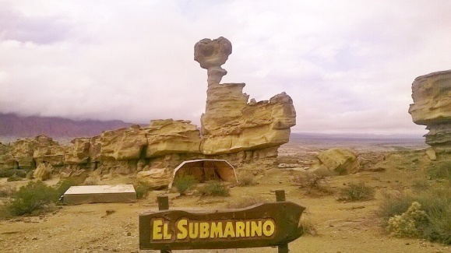
- The mushroom: It presents this striking shape as a result of the differential erosion of water between its base, formed by easily friable clays, and its sandy roof.
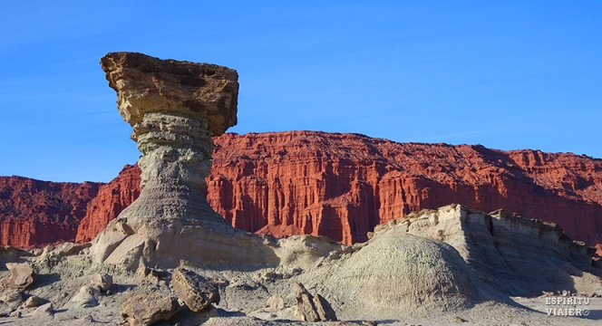
- Museum "Dr. William Sill": It shows you and explains how paleontologists work, the materials they use. This museum is named after the famous paleontologist William Sill.
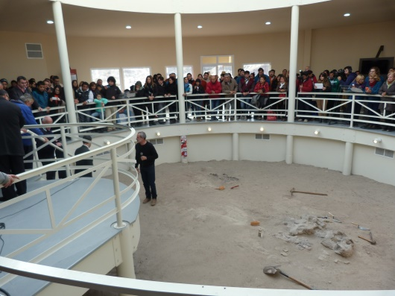
William Sill was an American paleontologist, precursor of the Ischigualasto investigation.
The best time to go is in autumn or spring
The tour lasts approximately three hours

Every month for 4 days they offer the Full Moon Circuit, as well as alternative trekking and mountain biking circuits. They also have great amenities at the base of the park such as a Movistar mobile phone signal, Wi-Fi, bathrooms, showers, a confectionery, an artisan center and a camping area.

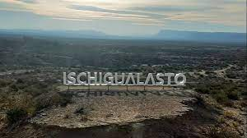

INTEGRANTES: Delfina Suarez, Lucrecia Ordoñez, Ada Oliva, Guillermina Sánchez y Guillermina Cibeira

