COOKIEES
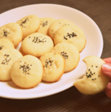
INGREDIENT
.500 GR RICE FLOUR
.2 EGGS
.200 GR ICING SUGAR
.200 ML OIL
.½ CUP SPOONS OF BAKING POWDER
.½ CUP ROSE WATER
1)Stir the sugar whit the egg yolk add keep the egg white.
2)Add the oil and mix everthing toghether.
3)Add flour and baking poder.
4)Mix the egg whites and fold them into the preparation.
5)Add the water and stir everthing toghether.
6)Making small balls with your hands.
7)Bake for 15 minutes and add the seeds.

