ISCHIGUALASTO

Questions and Answers:
A-How to get to ischigualasto?
We went to ischigualasto by bus taking the 150 route to Valle Fertil.
B-What time does the park open?
The park opens at 8am and closes at 5pm
C-How many stations can you find in the treditional circuit? Mention al lof them and take note of the most relevant information.
5 Stations: El Hongo- EL Submarino- LA Esfinge- LA Cancha de bochas- Valle pintado.
D-Which other circuits can you find a part from the traditional circuit? What can you do there?
The William Sill museum.
E-Which services does the park offer?
The park offers restaurants, bathrooms,children gemes and fair for shopping ítems.
F-Takes notes about who was William Sill and why was he important?
William Sill was born on july 30th 1937 and died in 2008. He wes 70 years old.
G-Take potos as much as posible for your task research.

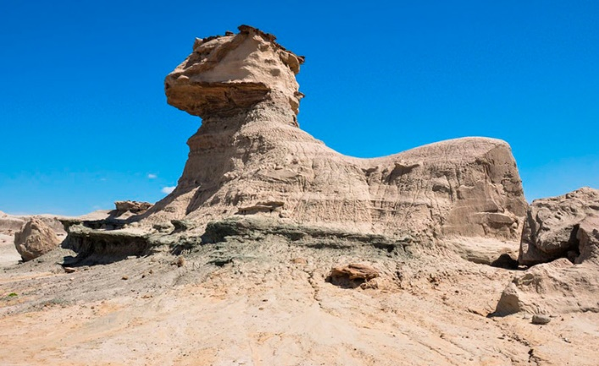
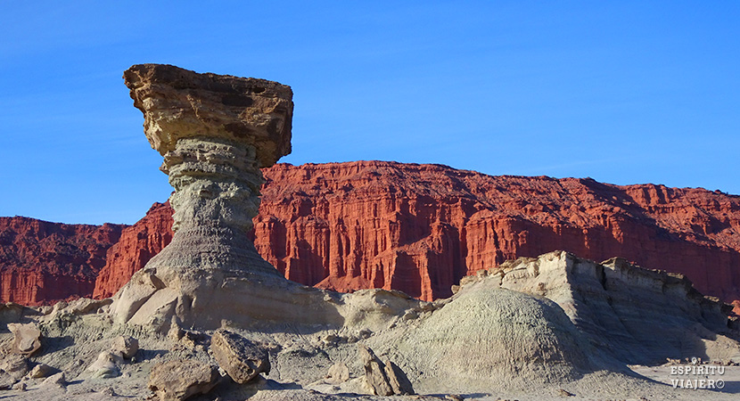
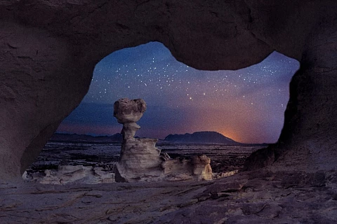
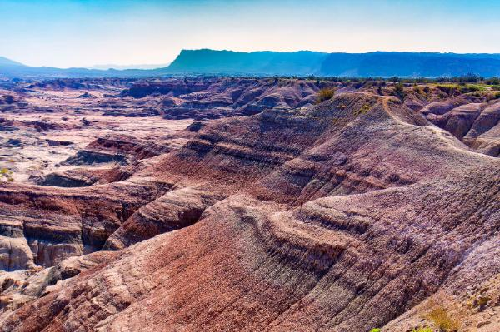
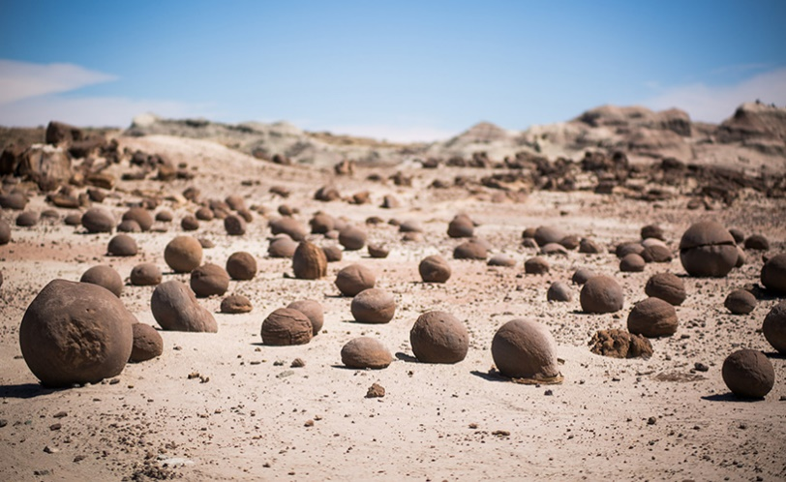

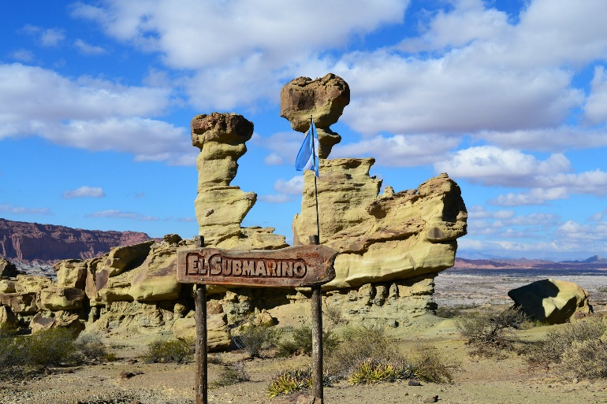

INTEGRANTES: Lujan Sánchez, Pierina Romero, Luis Rivero.
3ªB

