GUIA PERIODO DE FORTALECIMIENTO 3° AÑO
NAME:
COURSE:
TERCER TRIMESTRE
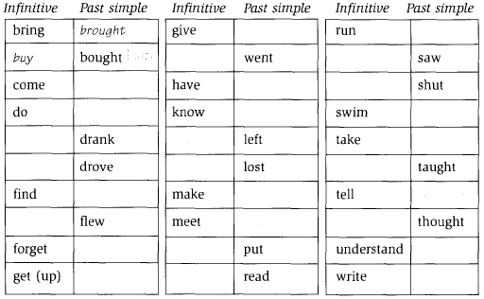
1. Complete with the correct verb in Past Simple

2. Complete with the correct form
My father __________ (go) to work by car yesterday
This morning I __________ (have) a shower.
My sister ___________ (not clean) her room on Saturday.
The birds _________ (fly) over our heads.
Last week my family __________ (buy) a new table for the dinning room.
The other day, I __________ (lose) my math's book.
I _______ (tell) my mother a lie.
We __________ (hear) a terrible sound outside last night.
_________ (you/see) the football match on Tuesday night?
Paul __________ (drink) a litre of coke for lunch yesterday.
3. Make negative sentences.
I phoned Lucy last night. → I Lucy last night.
You tidied up your room. → You ________ up your room.
Olivia became an actress. → Olivia______ an actress.
We found the treasure. → We _______ the treasure.
He spoke Spanish. → He _______ Spanish.
4. Complete with DID, WAS or WERE
____ he play video games?
____ you busy in the morning?
_____ I wrong?
_____ you fail in the test??
_____ the cat sleep in the sofa?

