GUIA PERIODO DE FORTALECIMIENTO 3° AÑO
NAME:
COURSE:
SEGUNDO TRIMESTRE
- Complet with the correct form of the verb present continuous
Jane ______ (do) the washing-up at the moment.
She thinks that her kids ______(run) around in the garden.
But they _______(play/not) in the garden.
Ben _______ (sit) in front of the TV.
He _________(watch) a film.
Emma _______(lie) on the sofa.
She _________(watch/not) TV.
2. Make interrogative sentences with present continuous.
- I/do/right/it
- you/sleep
- he/read/the paper
- They/play/football
- We/have/dinner/tonight
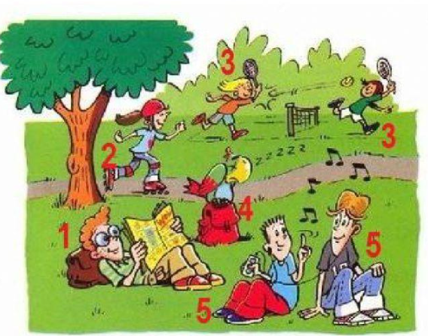
3. What are they doing? Write sentences

