PAST CONTINUOUS
MATCH THE PICTURES TO THE SENTENCES.
- HE WAS RUNNING IN THE PARK.
- SHE WAS WALKING HER DOG.
- THEY WERE HAVING BREAKFAST.
- I WAS WATCHING TV.
- THE CHILDREN WERE LISTENING TO MUSIC.


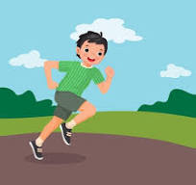

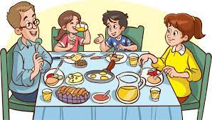
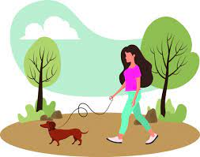

GREETINGS
MATCH THE SENTENCE HALVES
- We give… my hand but you didn’t see me in the crowd.
- She kissed… a high five when we make a good joke.
- I saw you and waved… Hi to my friends when we met at the festival.
- I said… me on the cheek.
- He smiled… at me but didn’t say a word.

