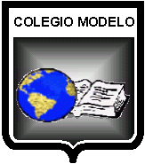
TEST UNIT 2
LENGUA EXTRANJERA: INGLÉS
CURSO: 4°”B”
PROFESORA: Georgina Rossi
ALUMNO/A: Victoria Lara
TEMAS EVALUADOS: Saludos. Pasado Continuo.

- MATCH THE IMAGES TO THE WORDS
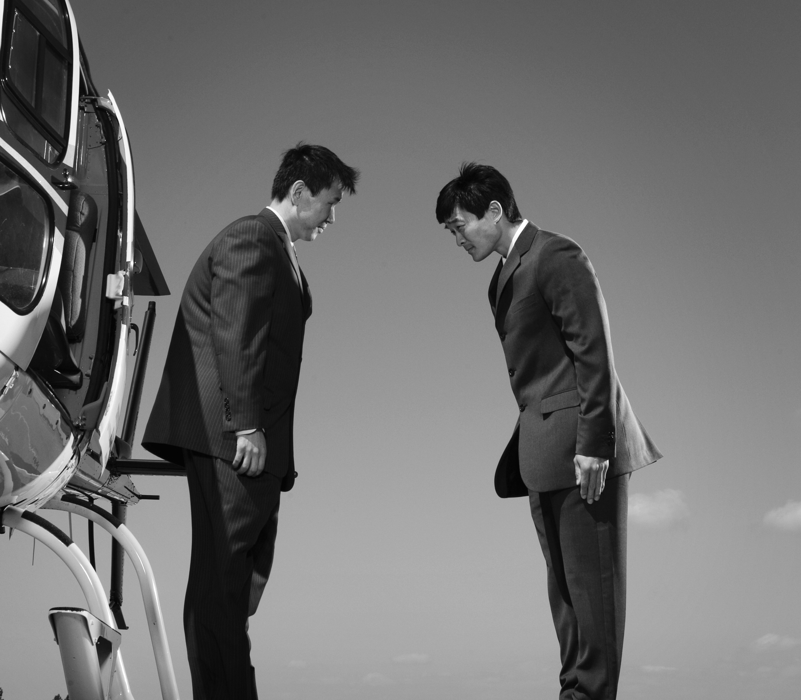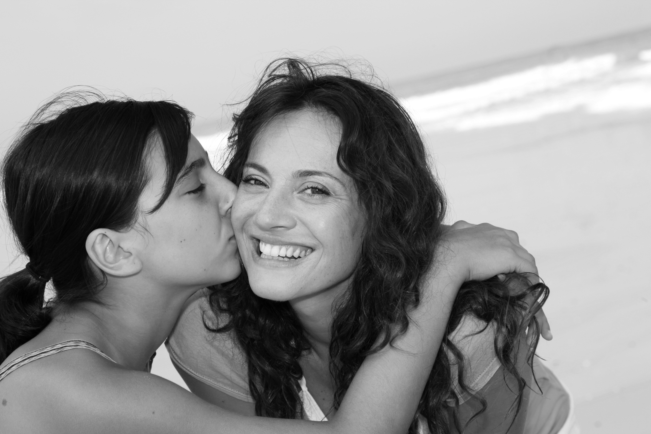

BOW HUG KISS ON THE CHEEK GIVE A HIGH FIVE SHAKE HANDS

- MATCH THE SENTENCES TO THE IMAGES.

- THEY WERE TAKING PART IN A COMPETITION.
- I WAS MAKING A DONATION.
- THEY WERE RAISING MONEY FOR CHARITY.
- SHE WAS BREAKING A RECORD.
- HE WAS RUNNING A MARATHON.

