HELLO KIDS!
WE ARE GOING TO REVIEW SOME TOPICS (VAMOS A REPASAR ALGUNOS TEMAS)

1)- LOOK AT THE PICTURES AND ANSWER THE 3 QUESTIONS. (RESPONDER LAS PREGUNTAS)

1 2 3

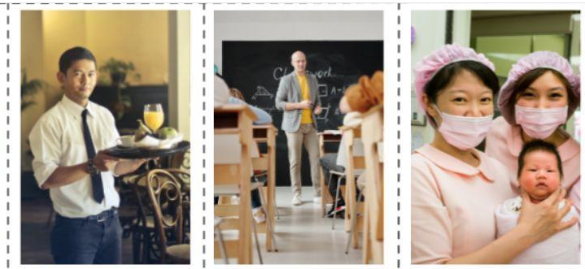
- What is your job? | 1. What is your job? | 1. What is your job?
- Where do you work? | 2. Where do you work? | 2. Where do you work?
- What do you do in your job? | 3. What do you do in your job? | 3. What do you do in your job?

2)- LOOK AT THE JOBS, RECOGNIZE AND COLOUR THE CORRECT ANSWER. (RECONOCER Y COLOREAR LA RESPUESTA CORRECTA)
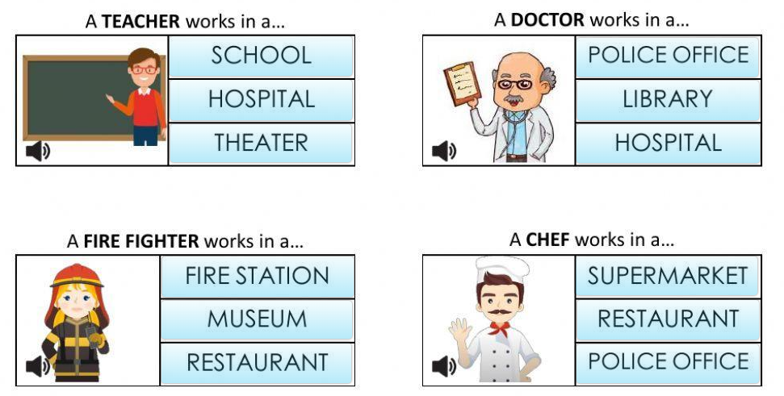
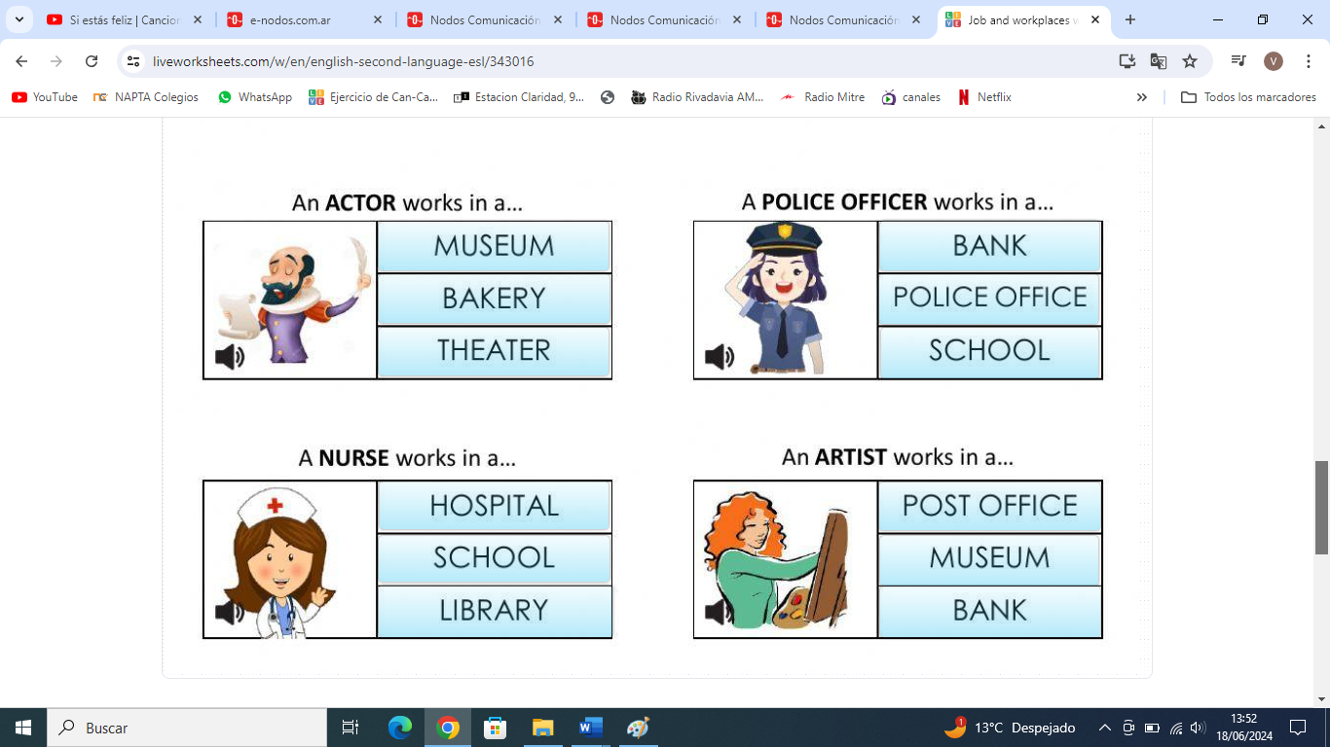

3)- LOOK AT THE MAP AND WRITE 7 SENTENCES USING PREPOSITIONS.
