this / that / these / those: Activity 1
Read Grammar bank 3B. Listen and complete the conversation.
Grammar bank
3B this / that / these / those
What’s this? It’s a key ring.
What are these? They’re key rings.
What’s that? It’s a cat.
What are those? They’re cats.
- We use this / these for things near you (things here).
- We use that / those for things that aren’t near you (things there or over there).
- this / that = singular, these / those = plural
- We also use this / that / these / those for people, e.g. This is my brother. Who are those girls over there?
this, that, these, those
This, that, these, and those are pronouns or adjectives.
This is my book. (= pronoun)
This book is very nice. (= adjective)

these this those that
Woman Excuse me. What are _________ ?
Man They’re T-shirts.
Woman How much are they?
Man They’re £15.
Woman And how much are _________ key rings?
Man They’re £6.
Woman And _________ mug?
Man £14.
Woman Is _________ a Manchester United shirt?
Man No, it’s Arsenal.
Woman How much is it?
Man £25.
Woman Oh…no. Thank you. Bye.

this / that / these / those: Activity 2
Complete the sentences.
- Those / That is a lovely picture. | 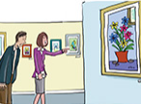
- A Is this / that a good hat?  B No, it isn't. | 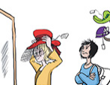
- These / Those are £10. | 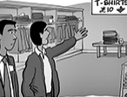
- A Are this / these your keys?  B Yes, they are. Thank you. | 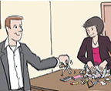
- Look! That / This 's Martin from our English class. | 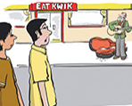
- Wow! Those / These are good glasses. | 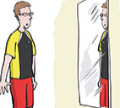

Souvenirs
Match the words to the pictures.
a cap a key ring a plate a teddy a mug
a football scarf a T-shirt a football shirt

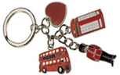 |  | 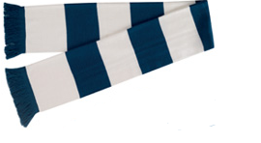
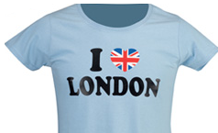 |  | 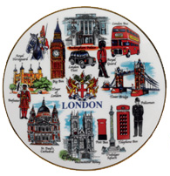
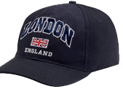 |  | 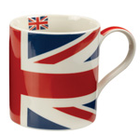
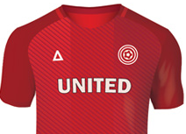 |  | 