“Colegio Merceditas de San Martín de CESAP”-2024-
Student´s name:……………………………………………………………………Course: 6 A B
Date:……………………………………………………………….. Teacher: Adriana Videla
ENGLISH TEST ( Unit II )
READING COMPREHENSION
-READ THIS AMAZING TEXT ABOUT SCHOOLS. THEN, DO THE ACTIVITIES BELOW THE TEXT.

DIFFERENT SCHOOLS- DIFFERENT RULES

Celebration School
In Celebration school children must go to classes twice a week. And they can choose the days they want to go. For example, Saturdays and Sundays! Students can also eat or drink or go to the kiosk if they want during the class. They mustn´t interrupt the teacher This school is for you!
Woodland Primary School
In Woodland Primary School children don´t sit on the chairs for hours. There aren´t any chairs, any desks or any boards! Students must meet their teachers in the forest at 8am, sit on the floor and follow the instructions. Pencils or paper is prohibited because it is not ecological. They must write with a stick on the soil. Such an amazing school!

“Colegio Merceditas de San Martín de CESAP”-2024-
Student´s name:………………………………………………………………………….Course: 6 A B
Date:……………………………………………………………………………………………Teacher: Adriana Videla
ENGLISH TEST ( Unit II )

1-Write TRUE or FALSE. Correct the false statements. ( 1x5=5p)

1-In Celebration School students must go to classes only twice a week._______________

2-Students mustn´t go out during breakfast time. It´s prohibited.__________________

3-In Woodland Primary School students must sit on their chairs for hours. ____________

4-In Woodland Primary School it is prohibited to use pencils. __________________

5- They use a stick to write on the soil. _________________________
2- Circle the correct answer according to the content of the text. ( 1x5= 5p)

1- In Celebration school students must / mustn´t choose two days to go to school.
2- They mustn´t / can go to buy sweets at the candy shop during the class.
3- They must / mustn´t interrupt the teacher.
4- In Woodland school the students are / aren´t kids.
5- This school is boring / amazing.
“Colegio Merceditas de San Martín de CESAP”-2024-
Student´s name:……………………………………………………………………………….Course: 6 A B
Date:………………………………………………………………………………………………….Teacher: Adriana Videla
ENGLISH WRITTEN TEST N° 2(Unit II ) (GRAMMAR)
3- MATCH THE PICTURES TO THE OBLIGATIONS AND PROHIBITIONS.(4x 2,5=5p)
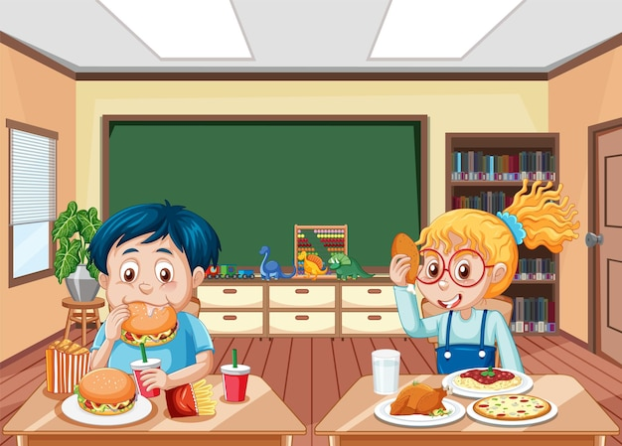
YOU MUSTN´T RUN IN THE CORRIDOR


YOU MUSN´T EAT OR DRINK


YOU MUST WEAR UNIFORM



YOU MUSTN´T CHEW GUM
4-COMPLETE WITH MUST , MUSTN´T OR CAN.(5x1= 5p)
GENERAL SCHOOL RULES
IN MERCEDITAS DE SAN MARTÍN DE CESAP SCHOOL:
1-STUDENTS ……………………………………. PLAY IN THE PATIO.
2-STUDENTS …………………………………….KEEP THE CLASSROOM CLEAN AND TIDY.
3-STUDENTS…………………………………… ASK FOR PERMISSION, FOR EXAMPLE:
…………………… I GO TO THE TOILET,PLEASE?
4-THE TEACHER ALWAYS SAYS, “ YOU ………………… STUDY VERY HARD.”
5-STUDENTS ……………………………………. INTURRUPT OR SHOUT IN CLASS.

