JULY, 31ST
- MATCH THE SENTENCES WITH THE IMAGES.
- I’LL SNOW TODAY.
- I’LL HELP YOU.
- I THINK THEY’LL WIN THE MARATHON.
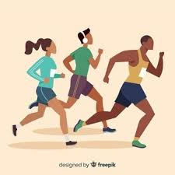

- LOOK AT THE PHOTOS AND COMPLETE THE SENTENCES.
SCIENTIST HOLIDAYS HAVE FLY

THEY ARE GOING TO________________TO BUENOS AIRES ON FRIDAY. 
I AM GOING TO BECOME A __________________ 

NICK IS GOING TO ____________________A PARTY. 
WHERE IS ALICIA GOING TO SPEND HER____________________.

