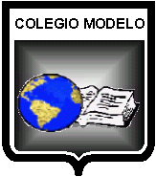
TEST UNIT 3
LENGUA EXTRANJERA: INGLÉS /40
CURSO: 4°”B”
PROFESORA: Georgina Rossi
ALUMNO/A:
FECHA:
TEMAS EVALUADOS: Simple Future. Going to Future.

- LOOK AT THE PICTURES AND MATCH THEM WITH THE PREDICTIONS.

- I THINK THAT IN THE FUTURE PEOPLE WON’T DRIVE NORMAL CARS.
- I BELIEVE THEY WILL GET MARRIED SOON.
- MY SISTER WILL BE A SINGER BECAUSE SHE LOVES SINGING.
- THERE WON’T BE ENOUGH CLEAN WATER IN THE FUTURE.

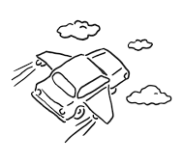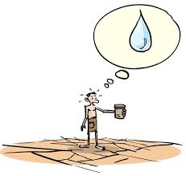

- LOOK AT THE PHOTOS AND COMPLETE THE SENTENCES WITH THE WORDS FROM THE BOX.
MOVE WEAR TRAVEL BECOME

- I AM GOING TO ________________TO THE SEASIDE TOMORROW. 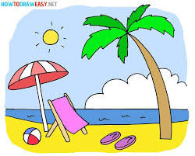
- HE IS GOING TO __________________A DOCTOR. 
- WE ARE GOING TO________________ TO PARIS NEXT YEAR. 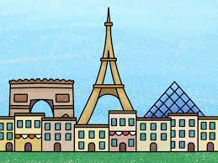
- ANNE IS GOING TO _______________A NEW RED DRESS FOR THE PARTY. 

