September, 19th
Guia de Contingencia.
- Reading comprehension: Read the text “Intelligence might be affected by pollution” and do activities 1,2 and 3 on page 52.
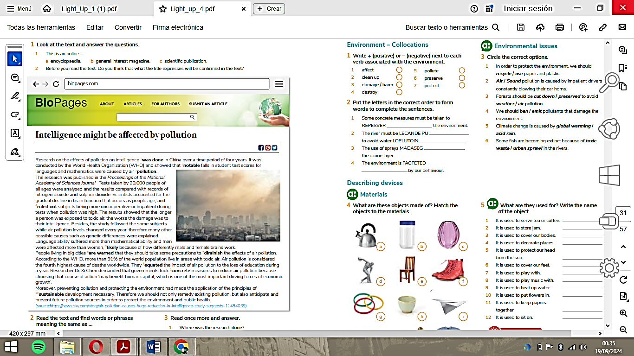
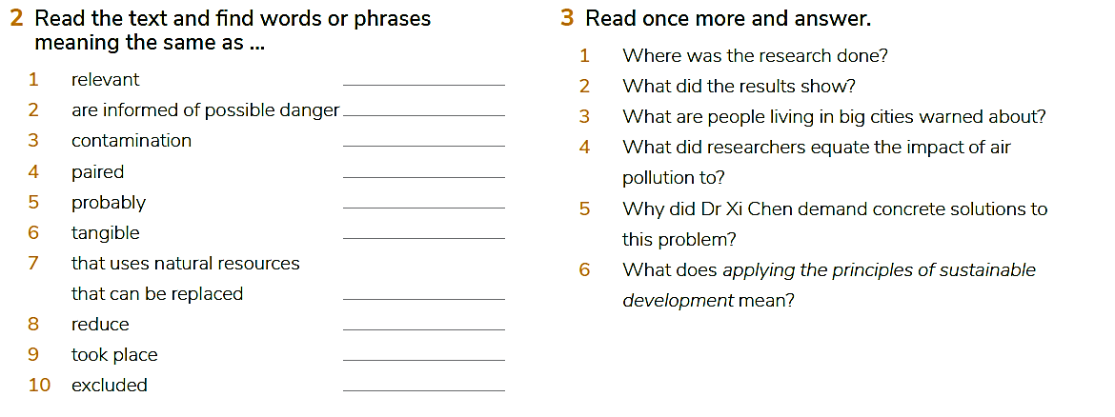
- Research about different types of pollution and mention examples in San Juan.

