September,19th
Guia de Contingencia N°1
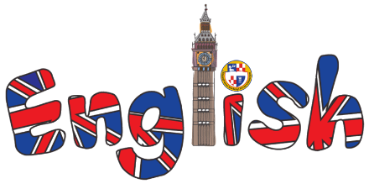
(COPIAR LA TAREA EN EL CUADERNO)
Past Simple :Regular and Irregular Verbs

1) Circle Regular Verbs.
go arrive do visit clean fly dance make
write play help wake get ride swim
study listen cook have give take
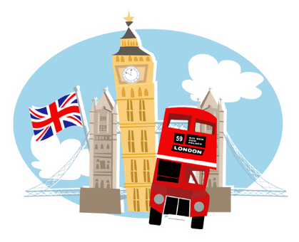
2) Circle Irregular Verbs.
go arrive do visit clean fly give
dance make write play help wake take
get ride swim study listen cook have

3) Match forms of Irregular Verbs.
go made
wake flew
make went

swim took
fly had
do got
get wrote
give woke
take swam
ride did
have gave
write rode
4) Write 6 examples in past Simple: affirmative or negative form.

