Good Morning my students of 4° A..!!!!
Let’s work from home..
English test – Mock (repaso para la prueba)
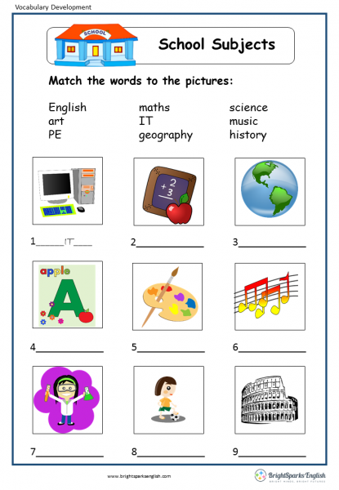

2) Unscrumble the days of the week and complete the crossword (ordena los días y complete el crucigrama)
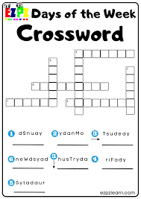

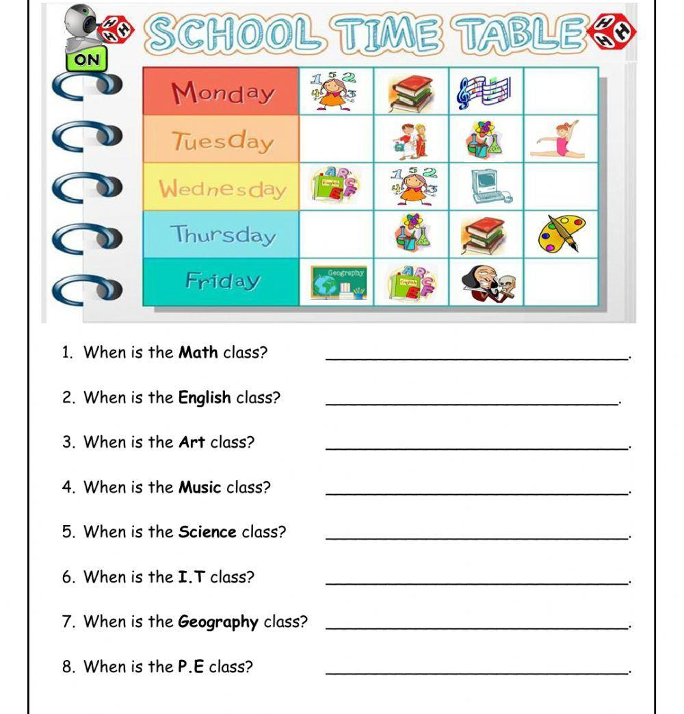

3) Answer the questions about you: (responde sobre tí)

Yes, I do. No, I don’t

- Do you like Maths?
- Do you like P.E.?
- Do you Like Religion?
- Do you like English?

