Reading comprehension
Read the text and do the following activities:

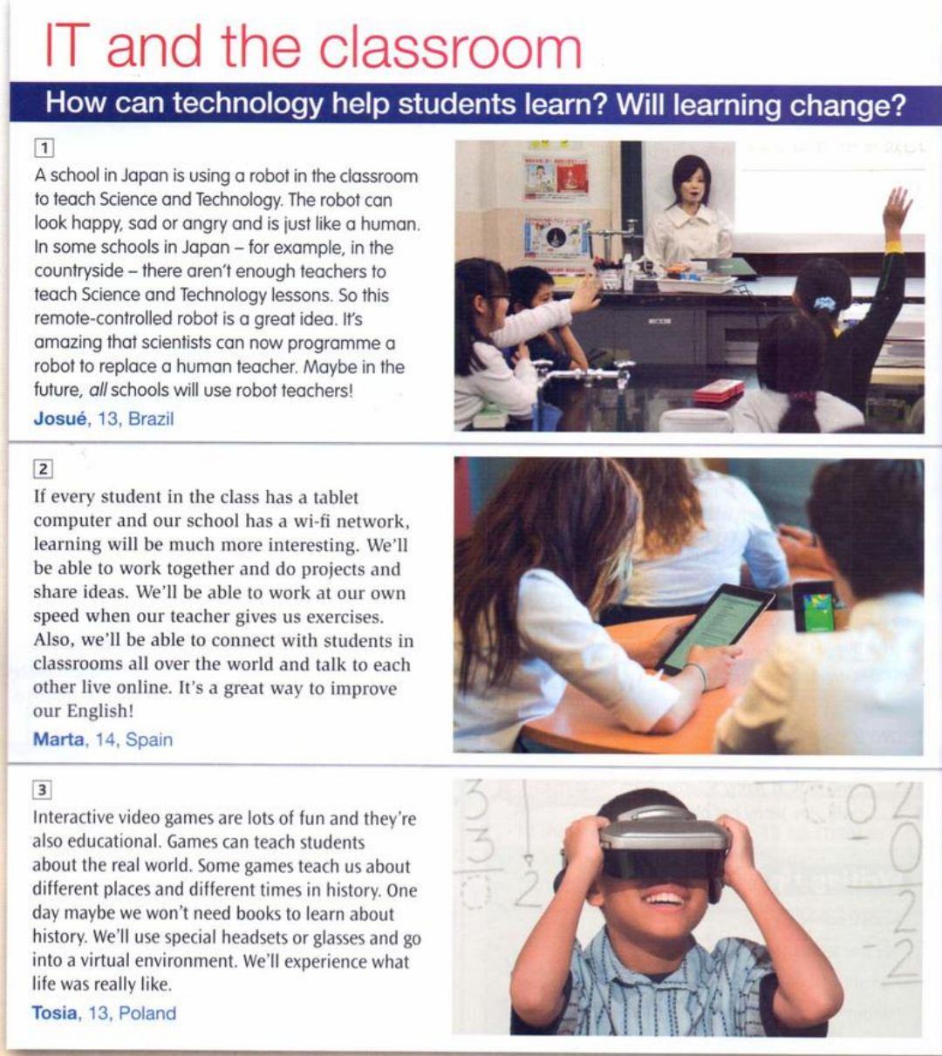

1-Match the headlines ( a-c) with paragraphs (1-3):

a-CLASSROOM WITHOUT WALLS…
b-PLAY AND LEARN…
c-NO MORE TEACHERS…

2- Read and Choose the correct option answers. There are two for each question :
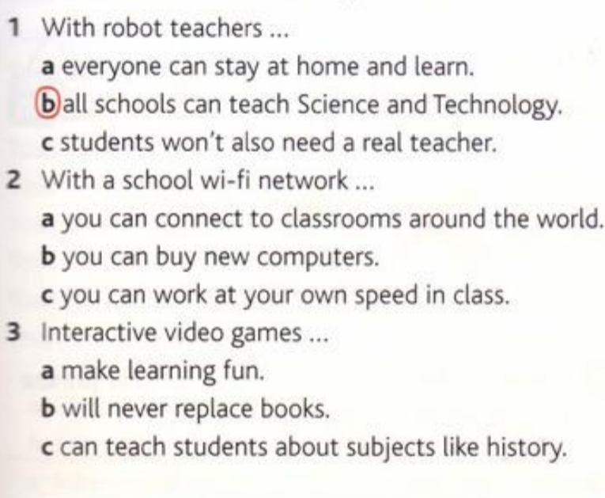
After reading the tex,think about the advantages and disadvantages of using technology in classroom. Make a list.

ADVANTAGES | DISADVANTAGES

Writing
Choose from the list below 3 ítems of technology to help students learn English. Then write a report about your choices.
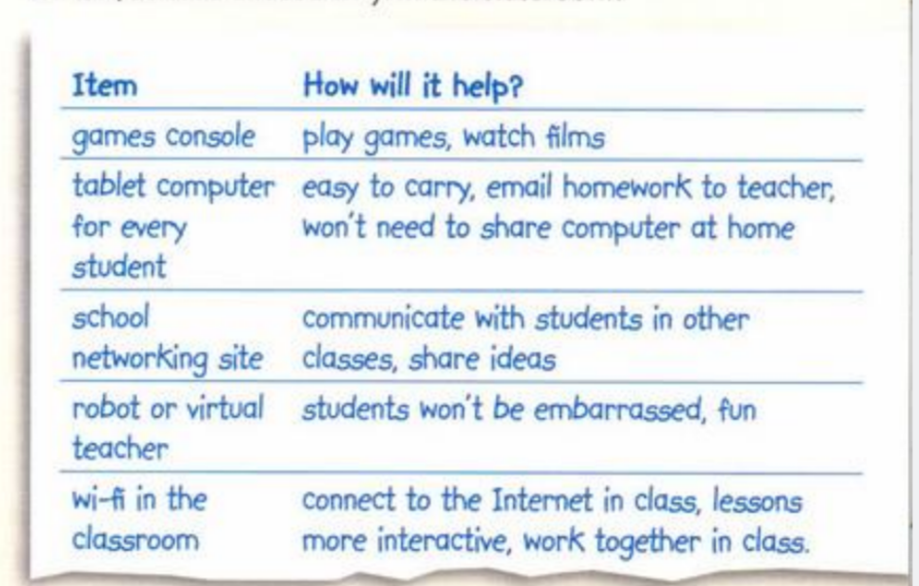
TECHNOLOGY THAT WILL HELP OUR SCHOOL

