Activity Unit 4: SCHOOL SUBJECTS
- Match the subjects with the pictures

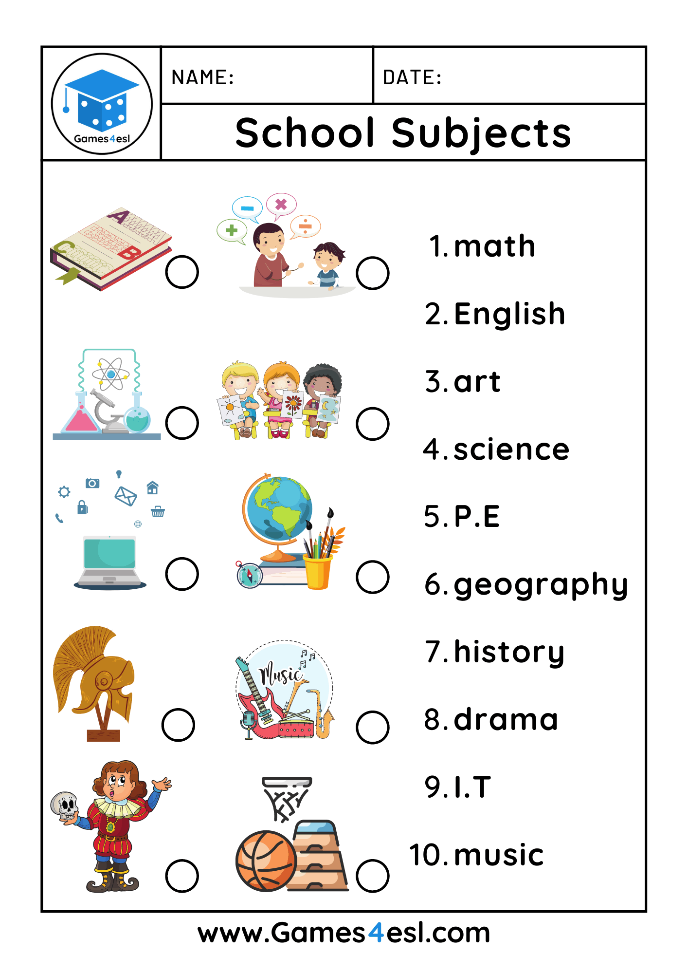
- Answer:
A) What is your favourite subject?
B) Do you like maths?
C) Do you like english?
3) Choose the correct word to the list and write the subjects:
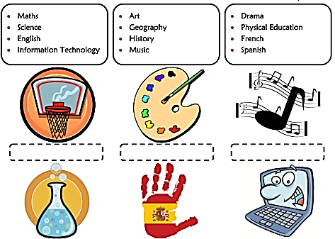
- Read and complete:
