Ariana and Bunny

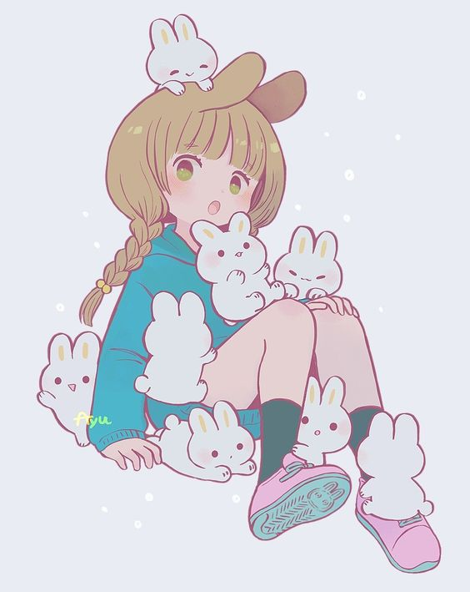
Robert
This is the story of a girl named Ariana , who one day went to her grandfather’s house. He had a very large farm in the back of his house, with animals like rabbits, horses, chickens and others animals. After eating she went to her garden and found a wishing pool, she closed to see what there was , as she closed she felt a great chill in her body and had a strage feeling but she didn’t give it any importance and went to see the others animals. The next day she got up, had breackfast and went to visit the animals. When she arrived she felt someone talking to her but she didn’t know where that voice was coming from. When she turned around she saw a bunny, she closed to her and asked: “What’s your name , bunny?”, the bunny sees her and respond : “ Robert , and you?, she is surprised to see that the bunny answers her and at that moment she realized that she could talk to animals. Just at that moment , her grandfather called her to take her home, but she didn’t want tos say “Good bye”, so the idea of taking her home ocurred to her , and that’s how it happened.
The days passed and Ariana and the bunny Robert became best Friends.
Meanwhile, Ariana duo realized that she could use that power to do Good and help the others animals that were in danger in the city.
WRITERS:
Sofia Olarte and Martina Frias. 3B

