“The Little fox in the City”



Once upon a time in a distant forest of the city, a Zoro accompained by his family, where the older brother Lucas, the younger sister Ari, the Bautista father, and Mother Flor leved togheter.
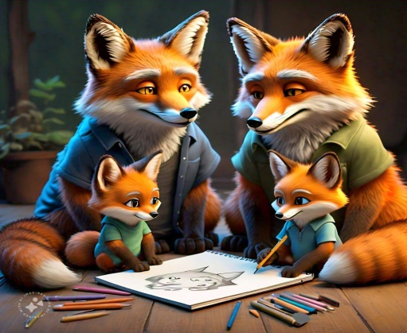
One day Lucas went out to explore while his didnot know, at that moment he met snakes that bit him , and he felt asleep when he woke up he did not know where he was , and he began to explore

the place and he looked quite cozy , after a while the

hole that opened a door and when he looked up a monkey called Francowas in front of him , Lucas trembling asked him that he was going there and the monkey answered “I was walking and I saw

you lying down , I assumed you needed help” and Lucas said “ I need to go back to my home there they are waiting for me” there the Franco monkey and Lucas went out in search of Lucas´ family.
When Lucas left the house , he realized that he was in serious trouble since he was in the city. On the way home , a very kind queen named Martina offered her help without expecting anything in return.
Then they embarked on a journey to the very distant forest without being sure if they could get Lucas to return home… They arrived in the forest and decided to separate , the queen went to the swap , the monkey to the volcano and the Little fox went to the fearful temple of the spiders.
The queen and the monkey managed to get out but Lucas was trapped in the small webs and at the moment when Lucas believed that he could never go out again , his father arrived in search of him , Bautista shouted loudly “Lucas , Lucas!!” And Lucas manged to answer “here I am dad” Bautista , I took Lucas from there and everyone celebrated his arrival , the queen and the monkey continued with their lives very happy just like everyone else.

WRITERS
Ariana Gasquez
Franco Armada

