ENGLISH
TAREA 27/9
- MATCH THE IMAGES WITH THE SENTENCES.
YOU MUST LISTEN TO THE TEACHER
YOU MUSTN’T USE YOUR PHONE IN CLASS.
YOU SHOULD PAY ATTENTION.
YOU SHOULDN’T GO TO BED LATE.
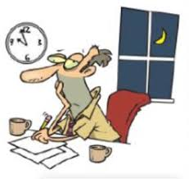

- WRITE THE PAST PARTICIPLE FORMS OF THESE VERBS:
- HAVE:
- GO:
- DO:
- MAKE:
- COME:
- BE:
- DRINK:
- EAT:

