COPIAR EN EL CUADERNO
October, 23th
Reading comprehension
- Read the text on page 100 and do activities 1,2 and 3.
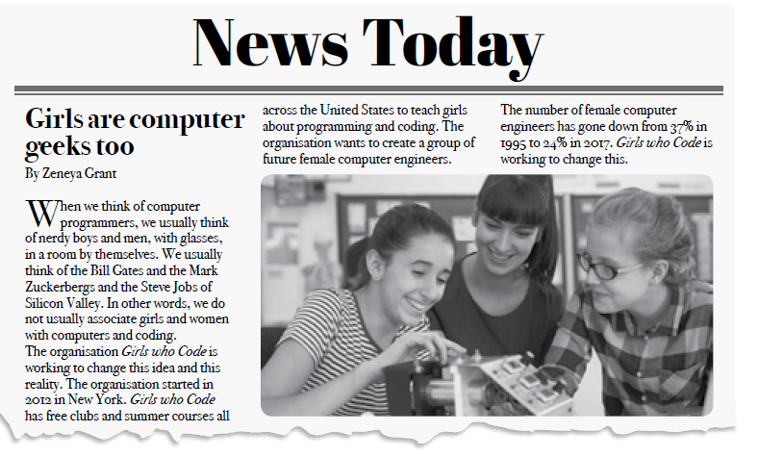
- Do activities 5,6,7 and 8 on page 102

SE CONTROLARÁ PROXIMA CLASE.

